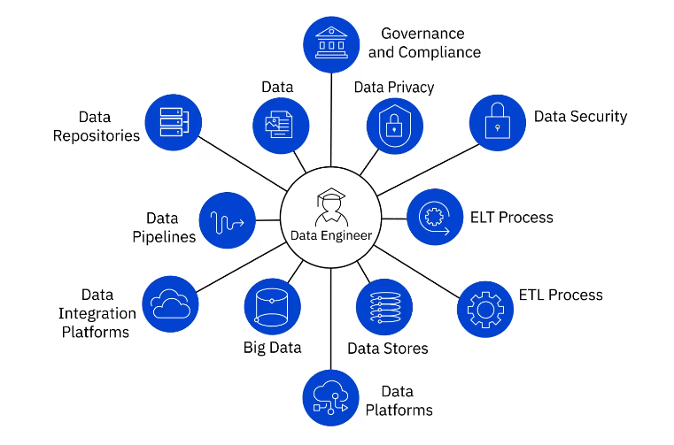

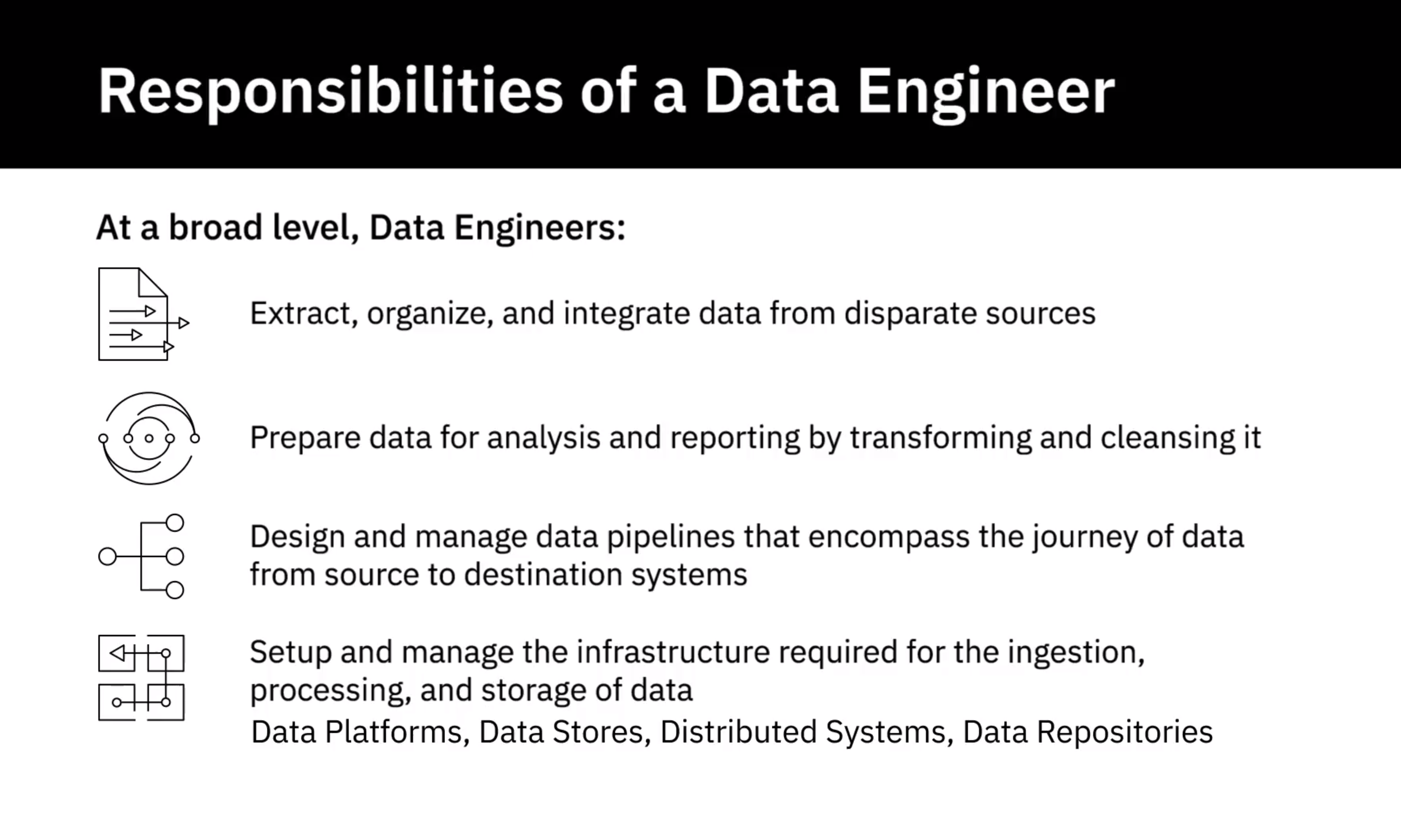

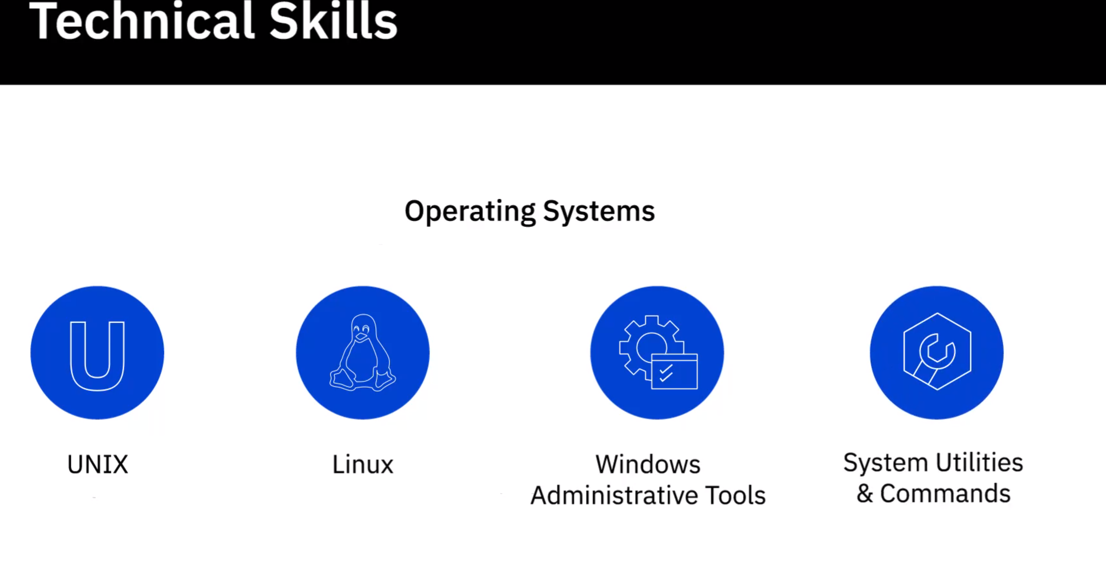

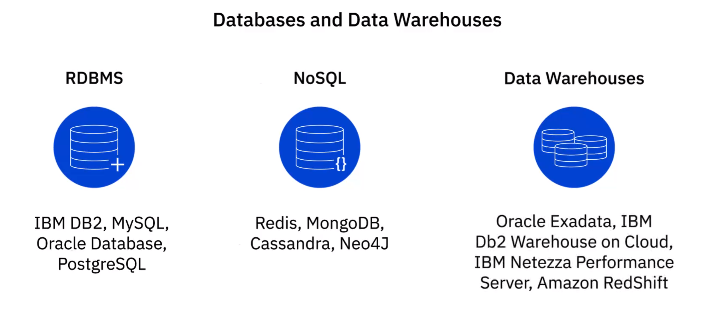

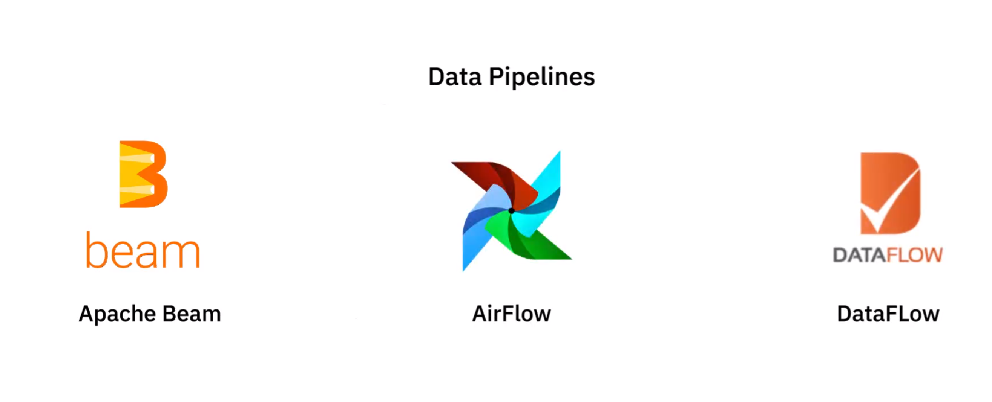



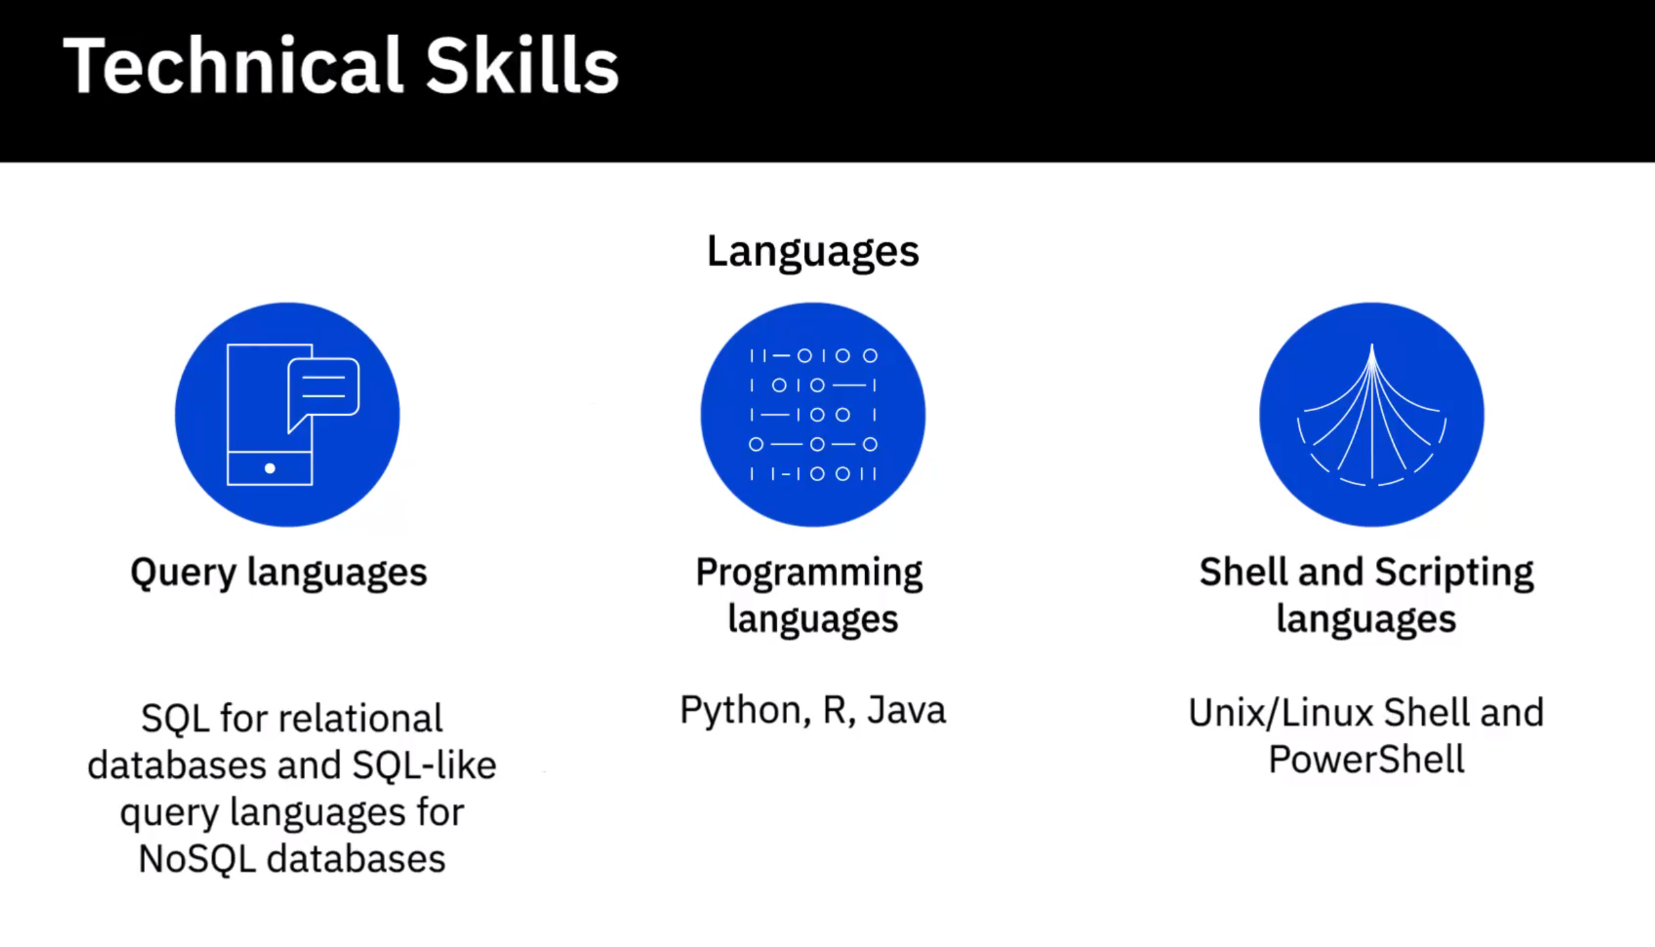

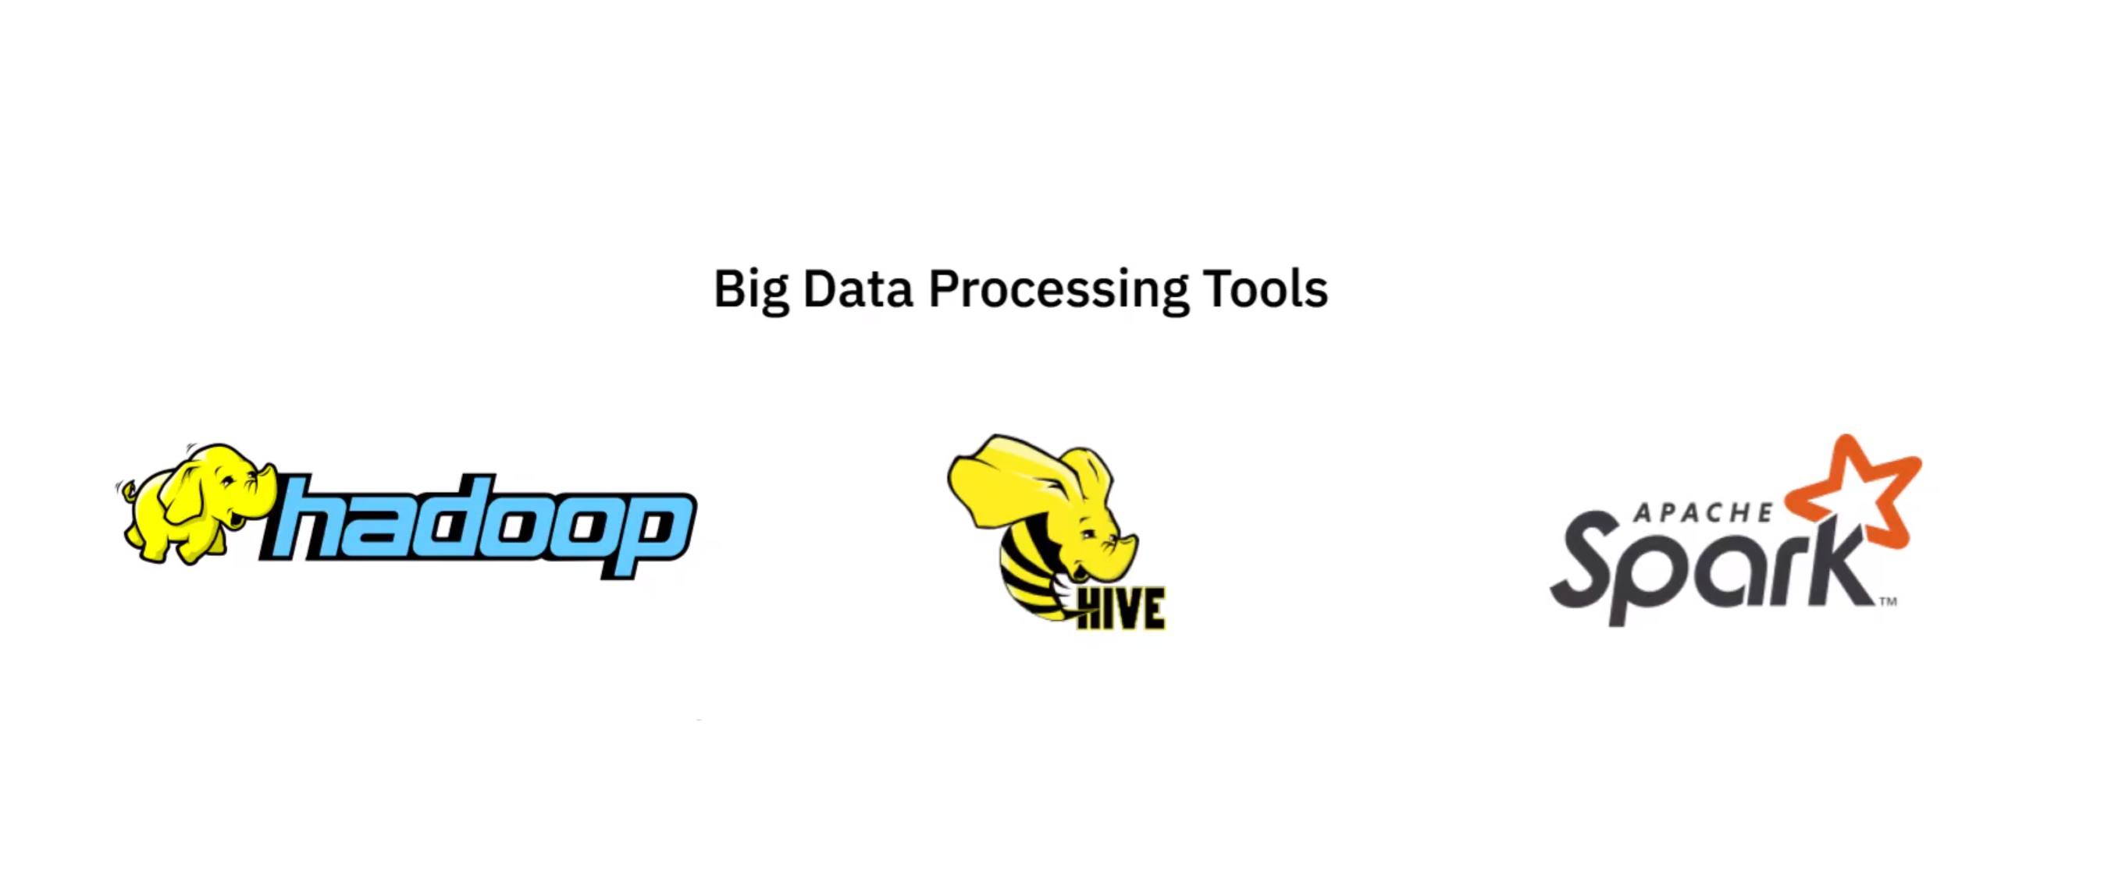

Functional Skills:

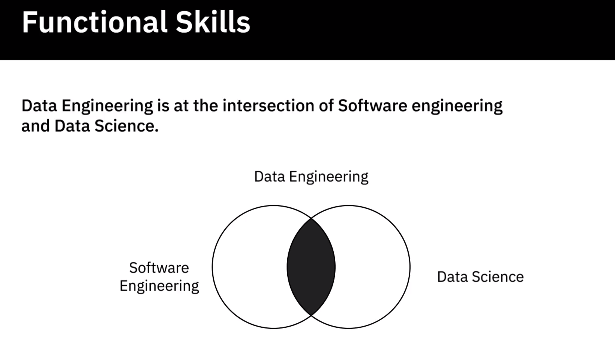

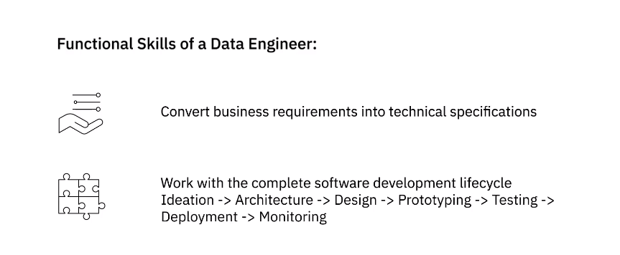

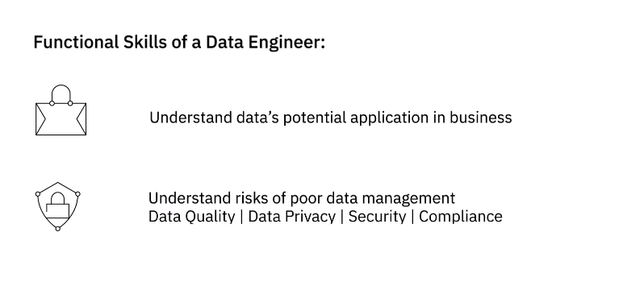

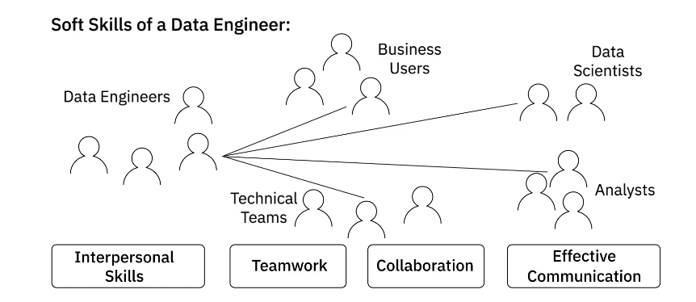

**Video: Viewpoints: Skills and Qualities to be a Data Engineer (6:58)**

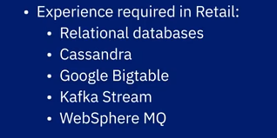

**Video: A Day in the Life of a Data Engineer (3:37)**

**Video: Overview of the Data Engineering Ecosystem (4:53)**

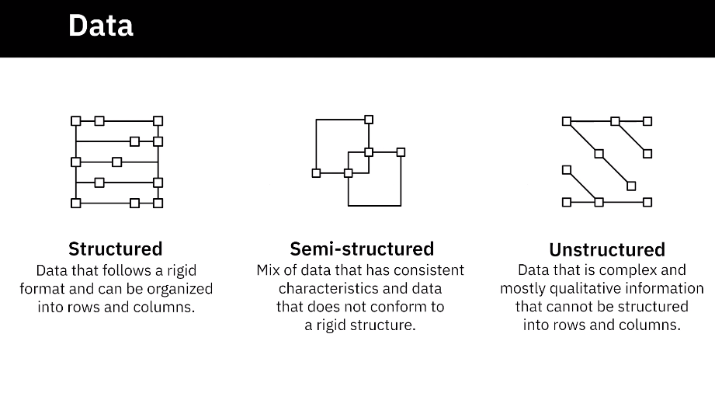

Data Sources

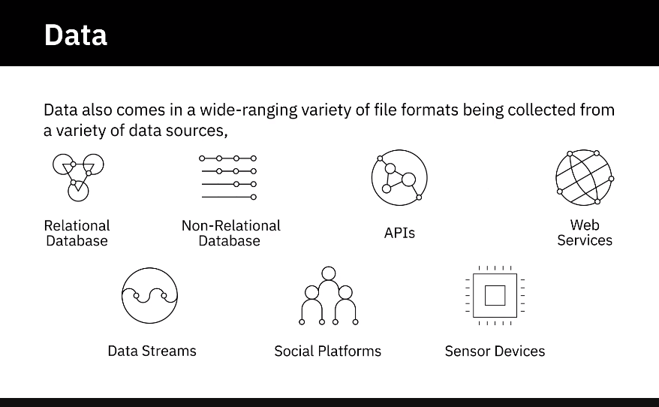

Data Repositories

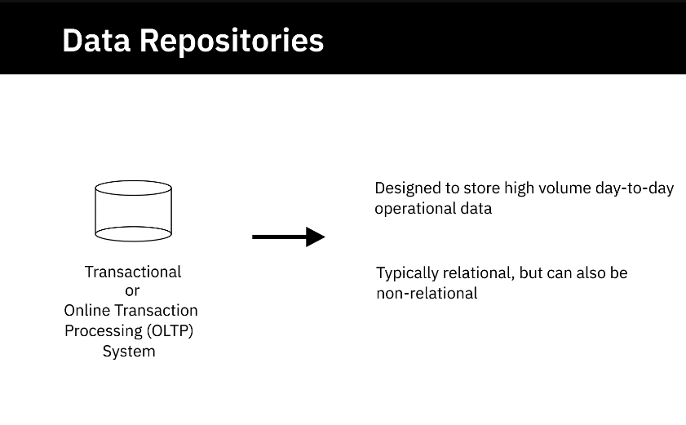

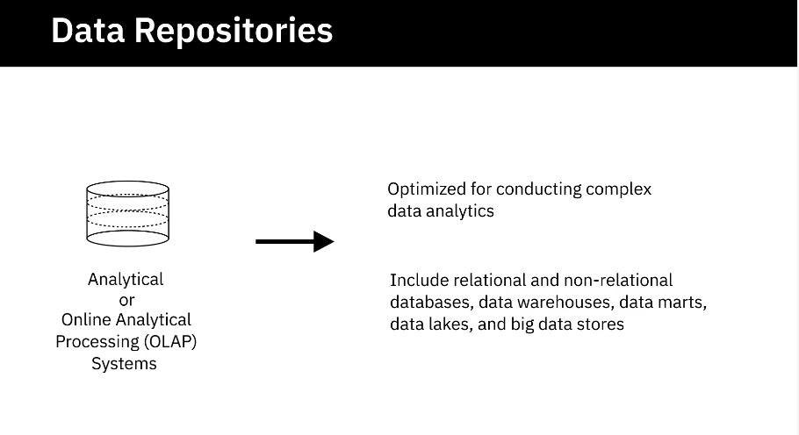

Data Integartion

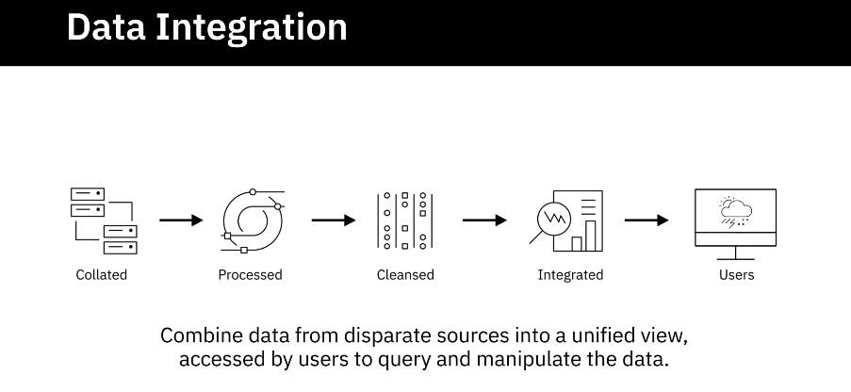

Data Pipeline

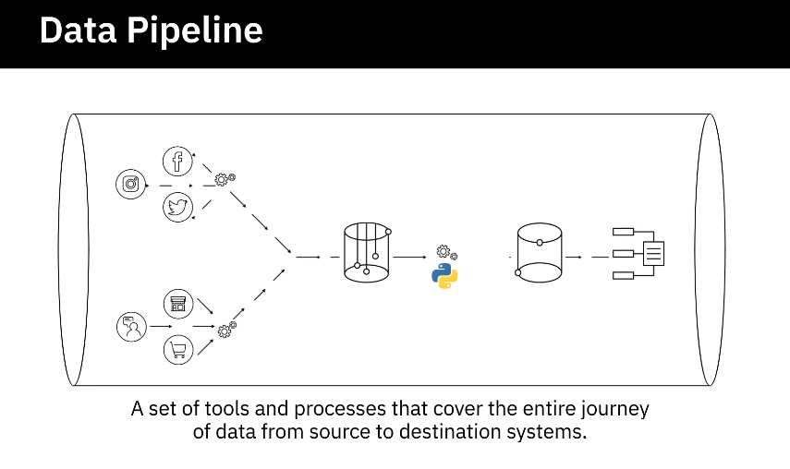

Languages

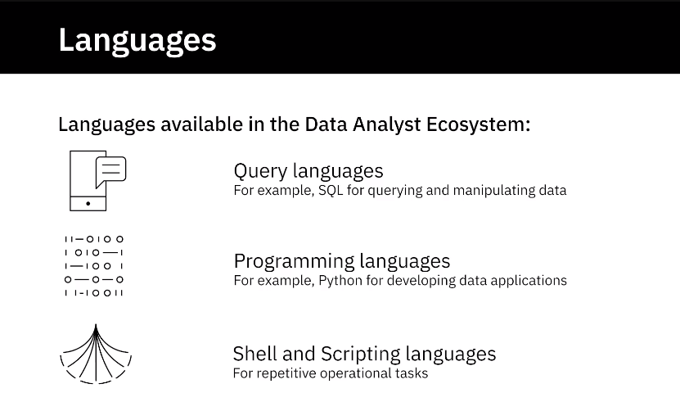

BI and Reporting Tools

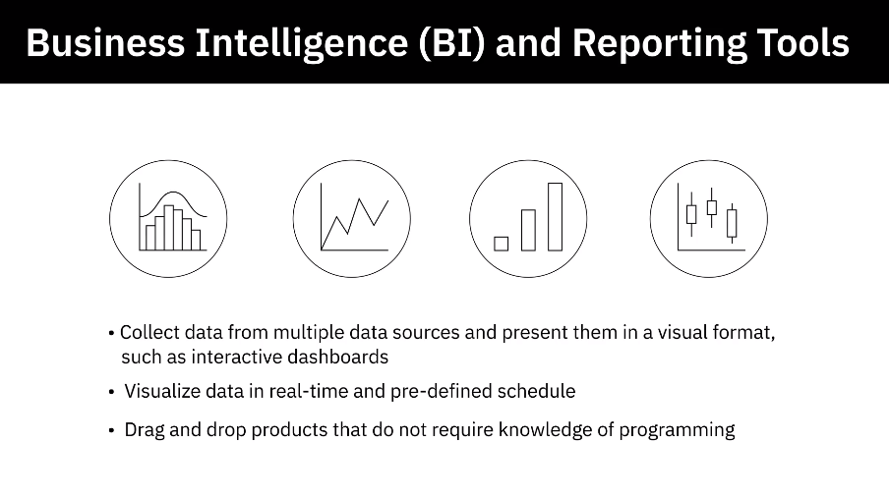

**Video: Types of Data (4:02)**

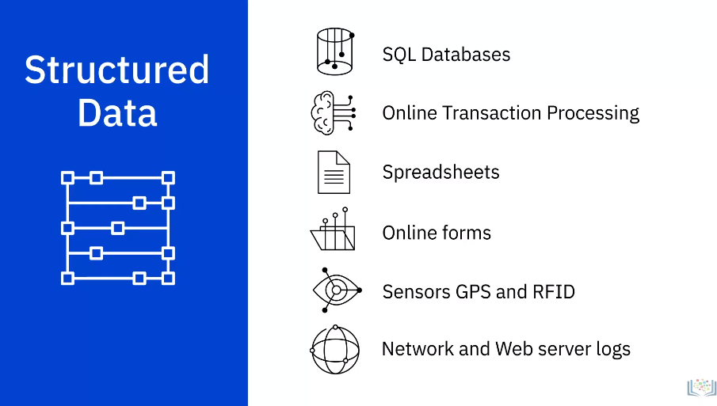

1. Structured data has a well-defined structure or adheres to a specified data model
2. can be stored in well-defined schemas such as databases
3. and in many cases can be represented in a tabular manner with rows and columns.
4. **Structured data is objective facts and numbers that can be collected, exported, stored, and**
5. organized in typical databases.
6. Some of the sources of structured data could include:
7. SQL Databases and Online Transaction Processing (or OLTP) Systems that focus on business transactions
8. Spreadsheets such as Excel and Google Spreadsheets
9. Online forms
10. Sensors such as Global Positioning Systems (or GPS) and Radio Frequency Identification
11. (or RFID) tags; and Network and Web server logs.
12. You can typically store structured data in relational or SQL databases.
13. You can also easily examine structured data with standard data analysis methods and tools.

**Video: Understanding Different Types of File Formats (5:00)**

CSV

XLSX

XML

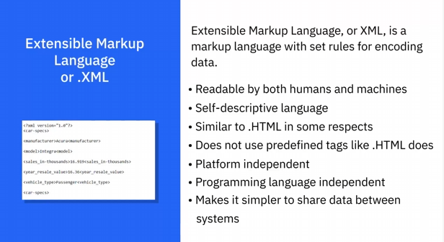

PDF

JSON

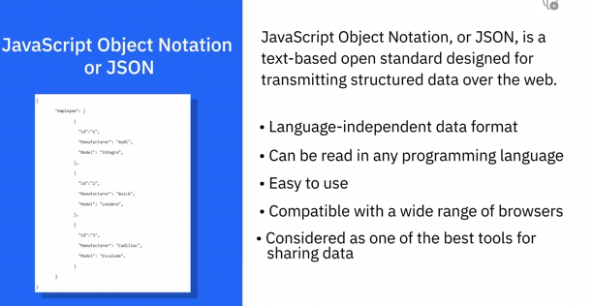

**Video: Sources of Data (7:57)**

**Common Sources of data**

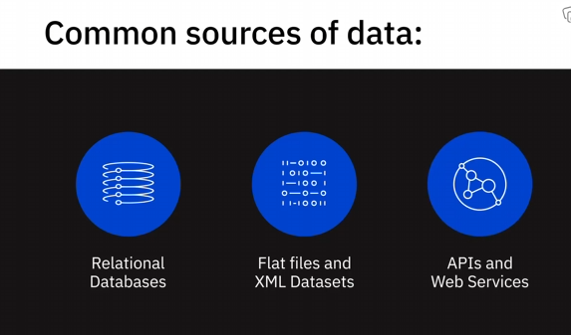

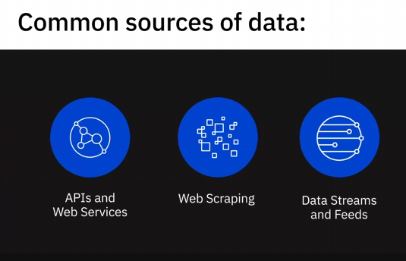

Relational Databases

Flat Files

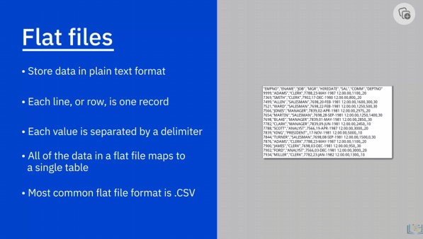

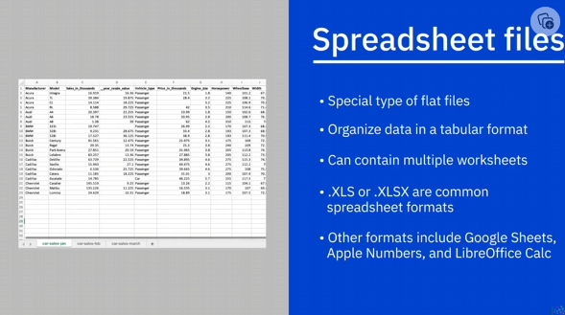

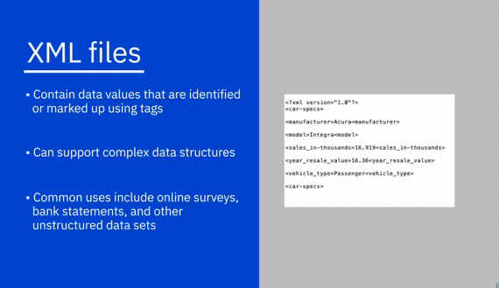

1. XML files, contain data values that are identified or marked up using tags.
2. While data in flat files is “flat” or maps to a single table, XML files can support
3. more complex data structures, such as hierarchical.
4. Some common uses of XML include data from online surveys, bank statements, and other
5. unstructured data sets.

APIs

1. Many data providers and websites provide APIs, or Application Program Interfaces, and Web
2. Services, which multiple users or applications can interact with and obtain data for processing
3. or analysis.
4. APIs and Web Services typically listen for incoming requests, which can be in the form
5. **of web requests from users or network requests from applications, and return data in plain**
6. text, XML, HTML, JSON, or media files.
7. Let’s look at some popular examples of APIs being used as a data source for data analytics:
8. The use of Twitter and Facebook APIs to source data from tweets and posts for performing
9. tasks such as opinion mining or sentiment analysis—which is to summarize the amount
10. of appreciation and criticism on a given subject, such as policies of a government, a product,
11. a service, or customer satisfaction in general.
12. Stock Market APIs used for pulling data such as share and commodity prices, earnings per
13. share, and historical prices, for trading and analysis.
14. Data Lookup and Validation APIs, which can be very useful for Data Analysts for cleaning
15. and preparing data, as well as for co-relating data—for example, to check which city or
16. state a postal or zip code belongs to.
17. APIs are also used for pulling data from database sources, within and external to the organization.

Web Scraping

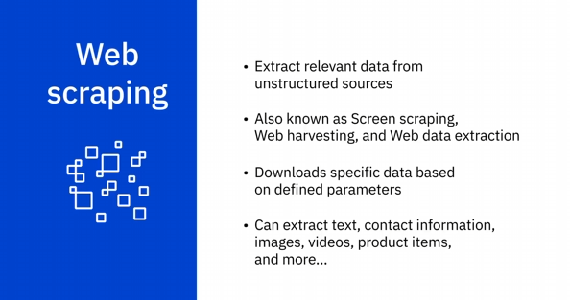

1. Web ScrapingWeb scraping is used to extract relevant data from unstructured sources.
2. Also known as screen scraping, web harvesting, and web data extraction, web scraping makes
3. it possible to download specific data from web pages based on defined parameters.
4. **Web scrapers can, among other things, extract text, contact information, images, videos,**
5. product items, and much more from a website.
6. Some popular uses of web scraping include
7. collecting product details from retailers, manufacturers, and eCommerce websites to provide
8. price comparisons;
9. generating sales leads through public data sources;
10. extracting data from posts and authors on various forums and communities;
11. and collecting training and testing datasets for machine learning models
12. Some of the popular web scraping tools include BeautifulSoup, Scrapy, Pandas, and Selenium.

Data Streams and Feeds

1. Data streams are another widely used source for aggregating constant streams of data flowing
2. from sources such as instruments, IoT devices, and applications, GPS data from cars, computer
3. programs, websites, and social media posts.
4. This data is generally timestamped and also geo-taggedfor geographical identification.
5. Some of the data streams and ways in which they can be leveraged include:
6. stock and market tickers for financial trading;
7. retail transaction streams for predicting demand and supply chain management;
8. surveillance and video feeds for threat detection;
9. **social media feeds for sentiment analysis;•sensor data feeds for monitoring industrial or farming**
10. machinery;
11. web click feeds for monitoring web performanceand improving design; and
12. real-time flight events for rebooking and rescheduling.
13. Some popular applications used to process data streams include Apache Kafka, Apache
14. Spark Streaming, and Apache Storm.
15. RSS (or Really Simple Syndication) feeds, are another popular data source.
16. These are typically used for capturing updated data from online forums and news sites where
17. data is refreshed on an ongoing basis.
18. Using a feed reader, which is an interface that converts RSS text files into a stream
19. of updated data, updates are streamed to user devices.

**Video: Languages for Data Professionals (8:20)**

SQL:

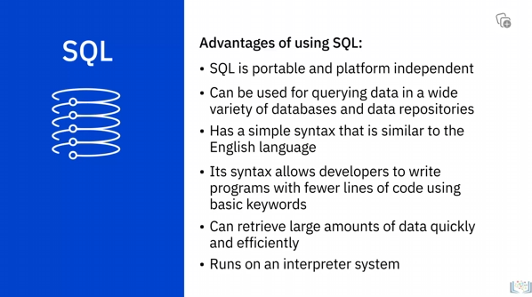

Python

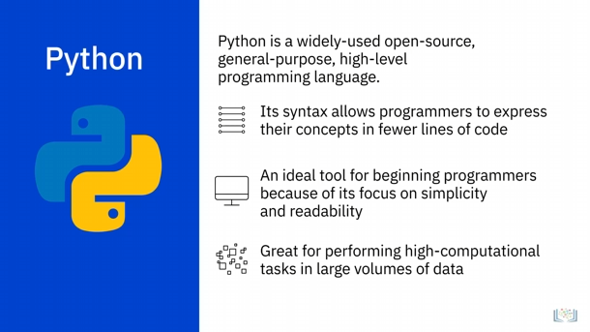

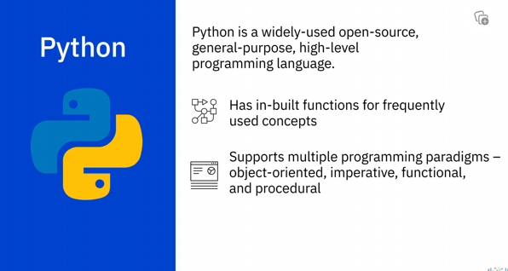

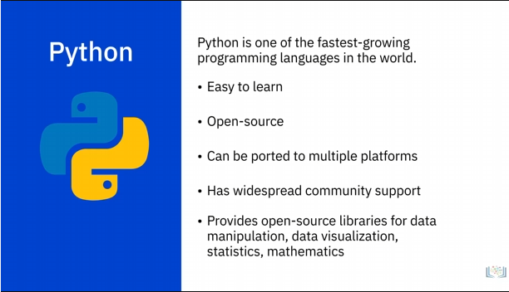

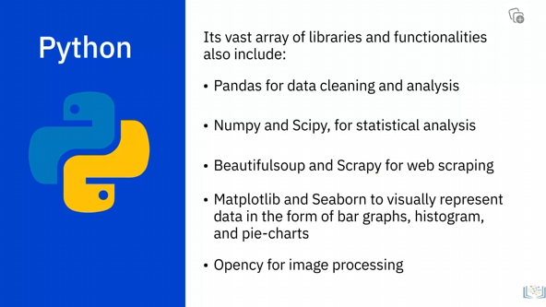

R

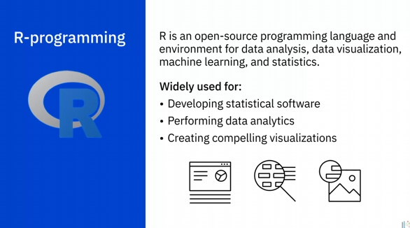

R Benefits

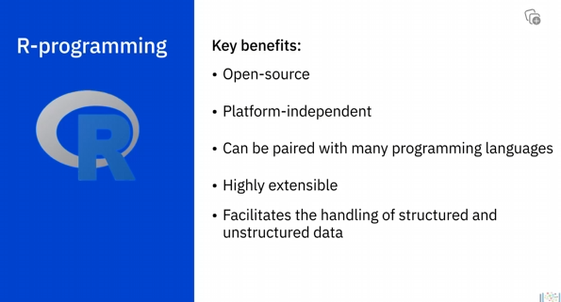

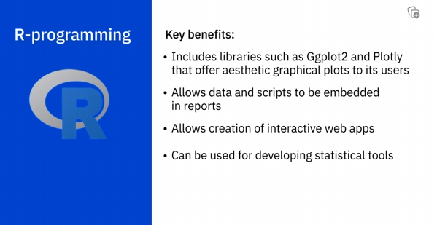

Java

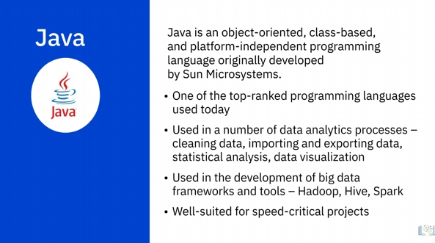

Unix/Linux Shell

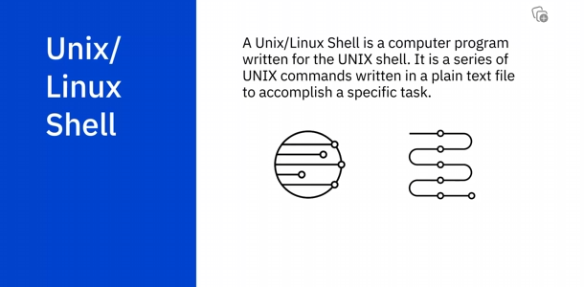

PowerShell

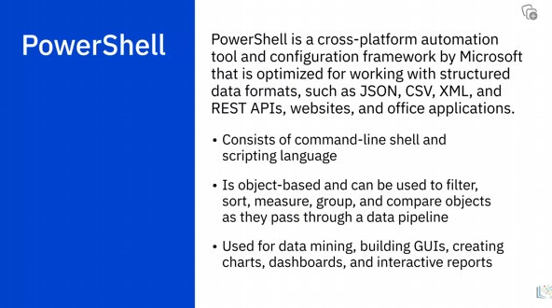

**Video: Viewpoints: Working with Varied Data Sources and Types (6:38)**

Flexibility

Cassandra and Hbase: for solving problems

Heavy write application

Variety of data sources

Pros and Cons of Different Data Formats

Apache Arvo: efficiency of storage of data

**Video: Overview of Data Repositories (4:34)**

Data Repositories Introduction

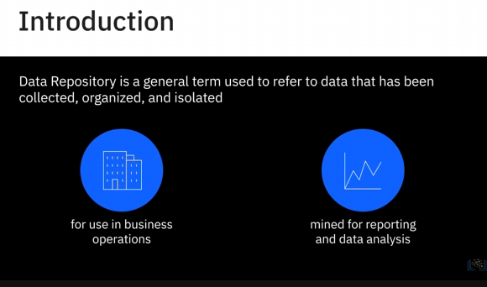

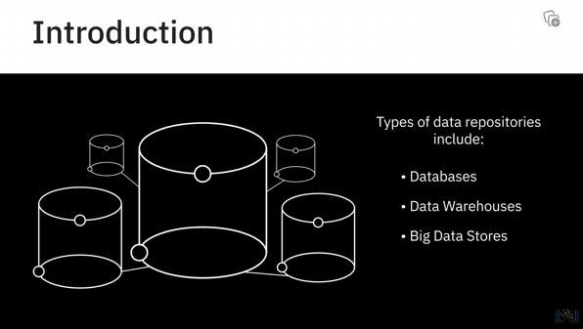

Databases

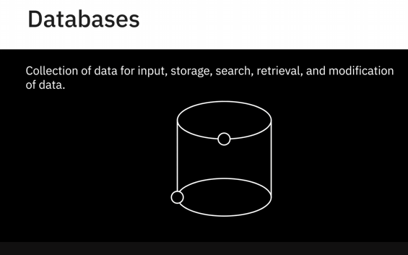

Database Management System/ DBMS

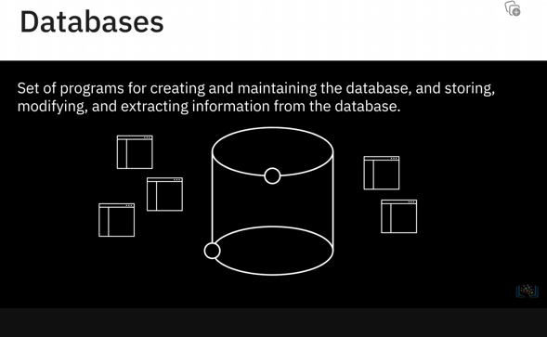

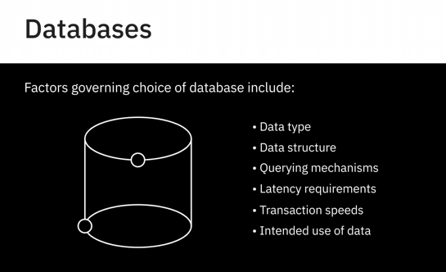

Relational Database:

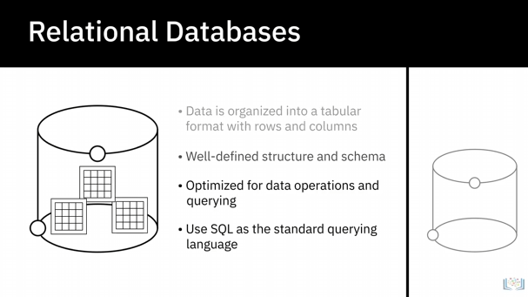

Non-Relational Database

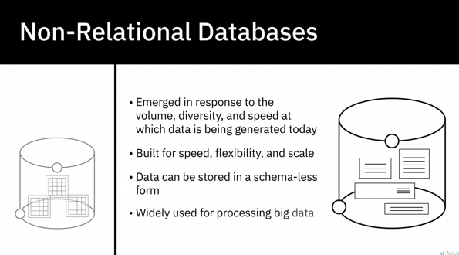

Data Warehouse

1. A data warehouse works as a central repository that merges information coming from disparate
2. sources and consolidates it through the extract, transform, and load process, also known as
3. **the ETL process, into one comprehensive database for analytics and business intelligence.**

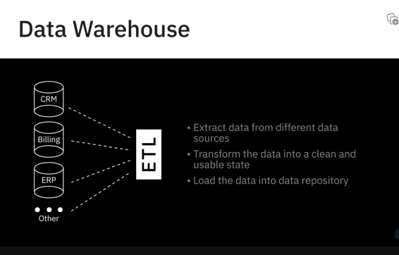

Data Marts and Data Lakes

Big Data Stores

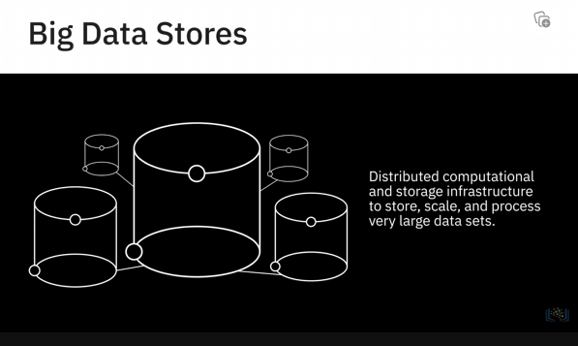

**Video: RDBMS (7:38)**

**A relational database is a collection of data organised into a table structure, where the tablkes can be lineked, or ralted, based on the data common to each**

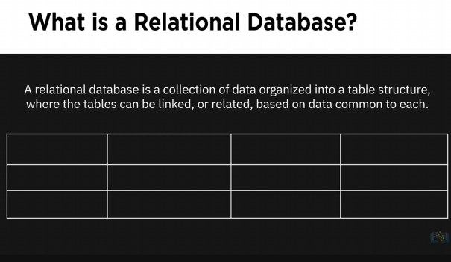

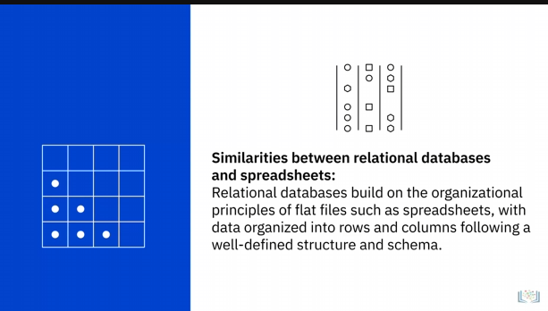

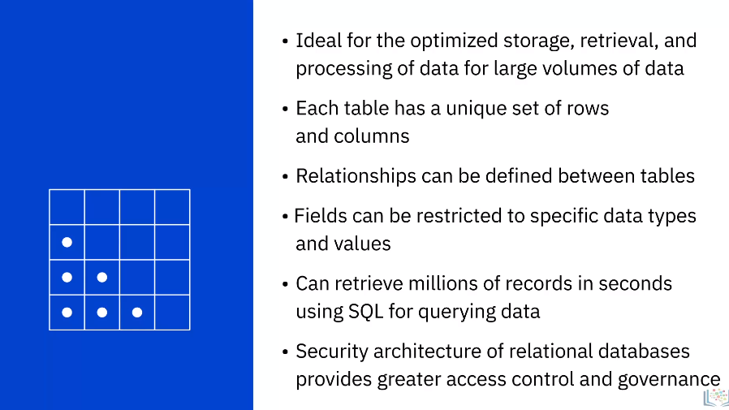

Examples of RDBMS

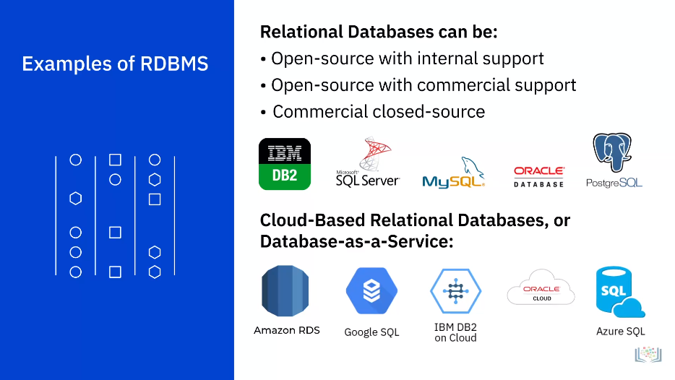

Advantages of Relational Database Approach

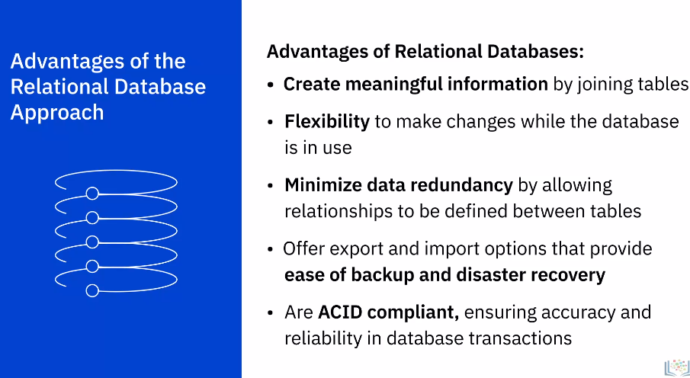

1. ACID-compliance: ACIDstands for Atomicity, Consistency, Isolation, and Durability.
2. **And ACID compliance implies that the data in the database remains accurate and consistent**

RDBMS Use Cases

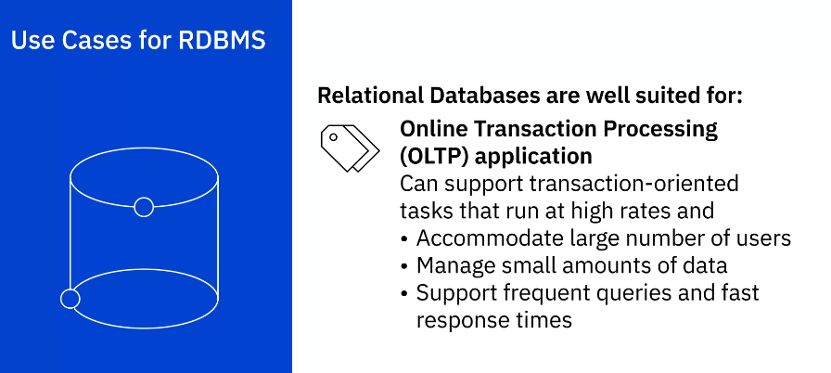

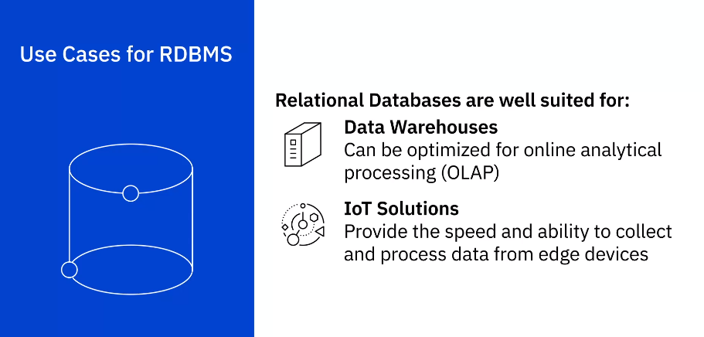

Limitations of RDBMS

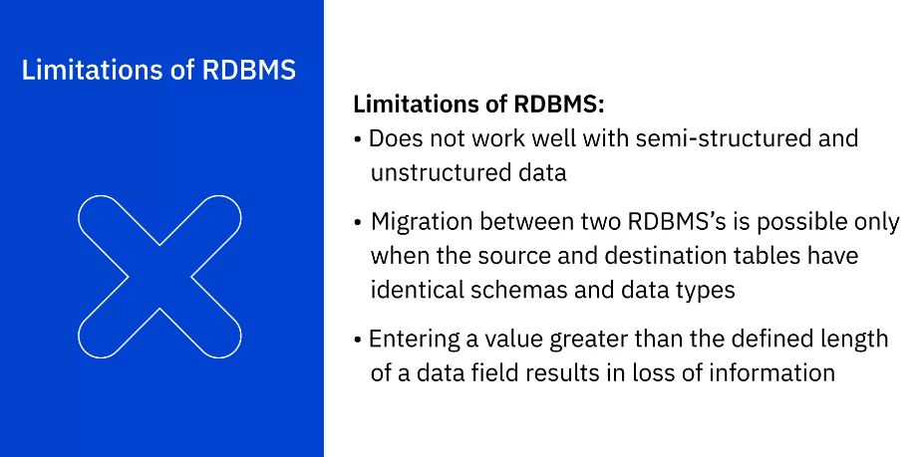

**Video: NoSQL (7:35)**

What is NoSQL database

Not only SQL

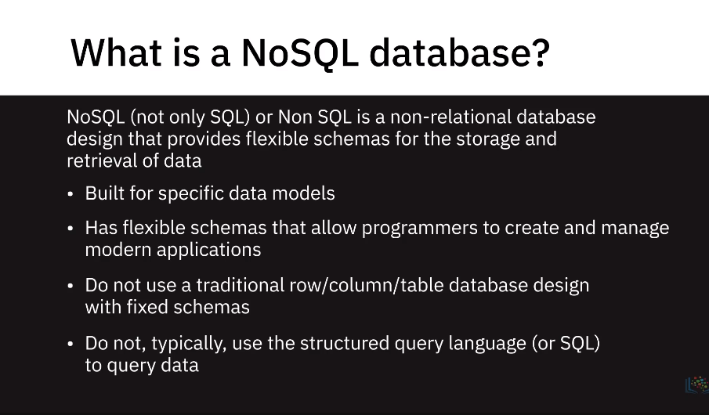

Schema-less or Free-form Fashion

Key value store

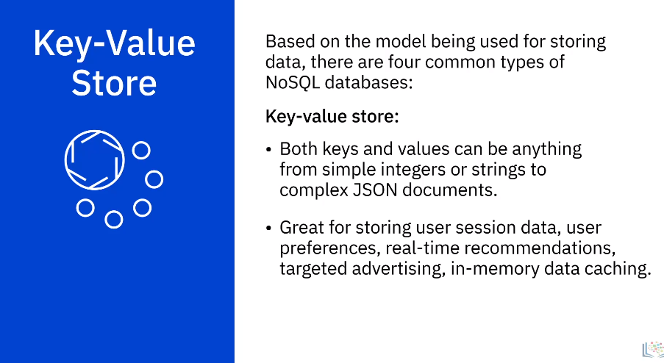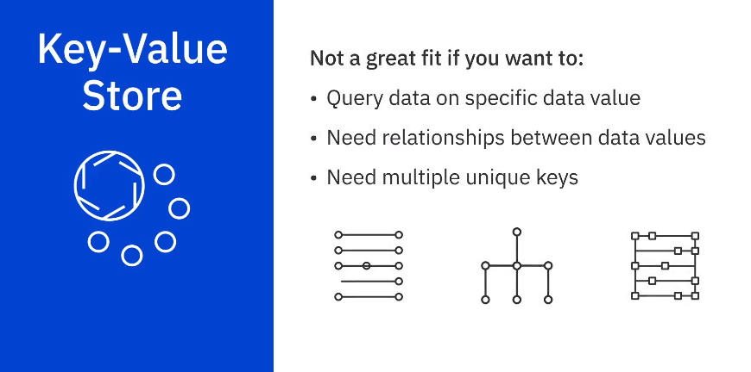

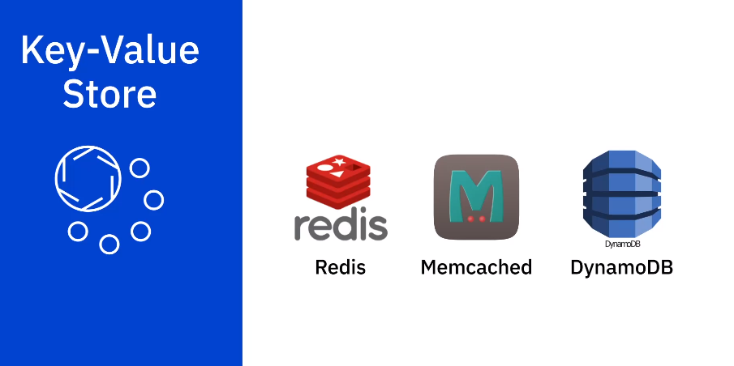

Document Based

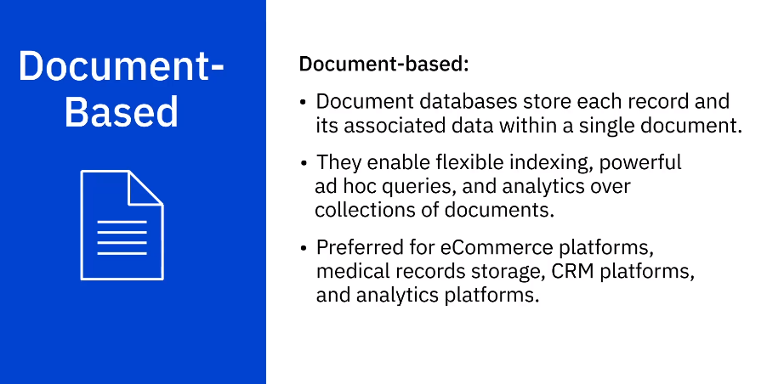

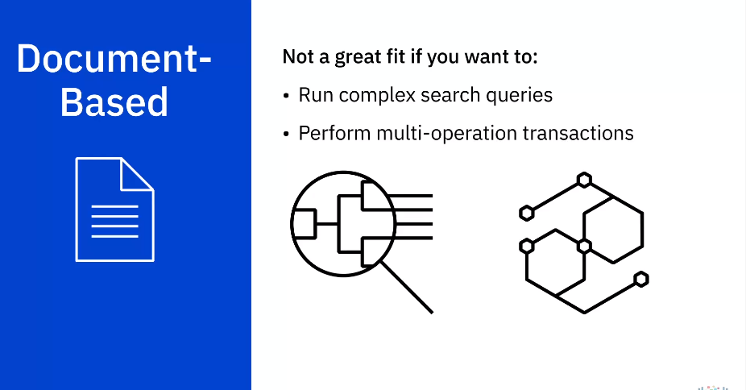

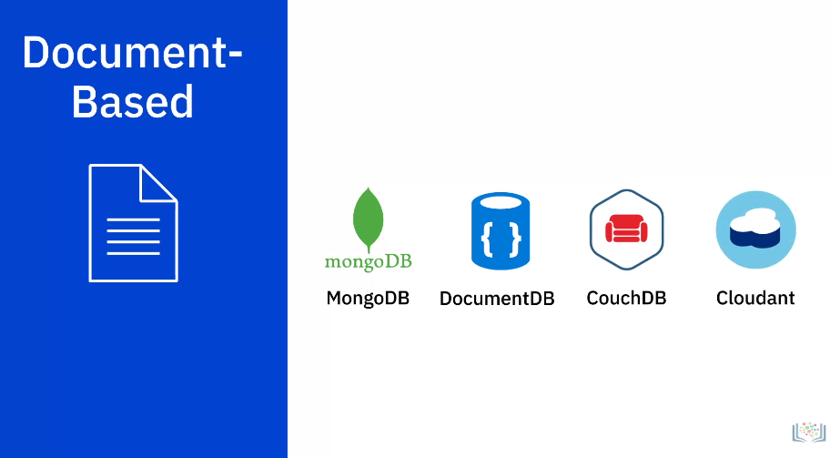

Column Based

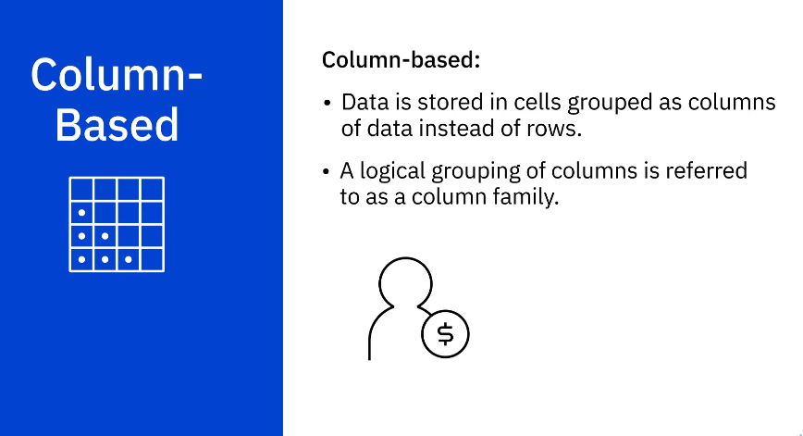

1. For example, a customer’s name and profile information will most likely be accessed together
2. but not their purchase history.
3. **So,customer name and profile information data can be grouped into a column family.**
4. Since column databases store all cells corresponding to a column as a continuous disk entry, accessing
5. and searching the data becomes very fast.

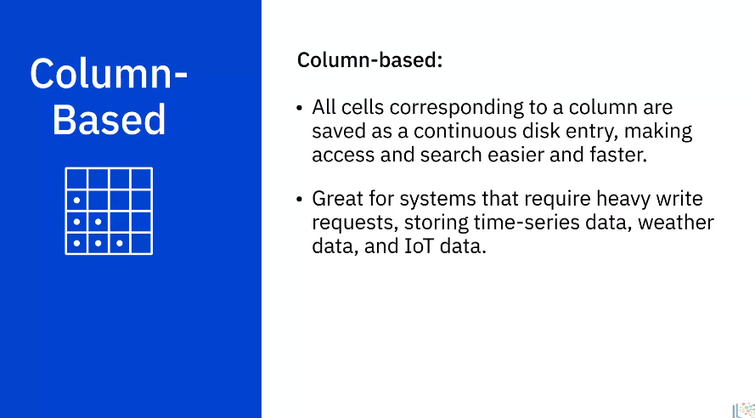

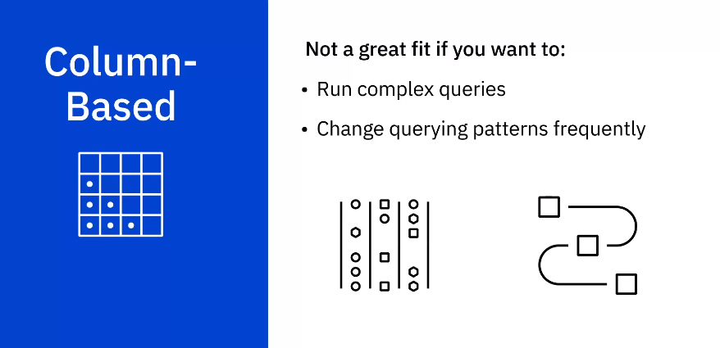

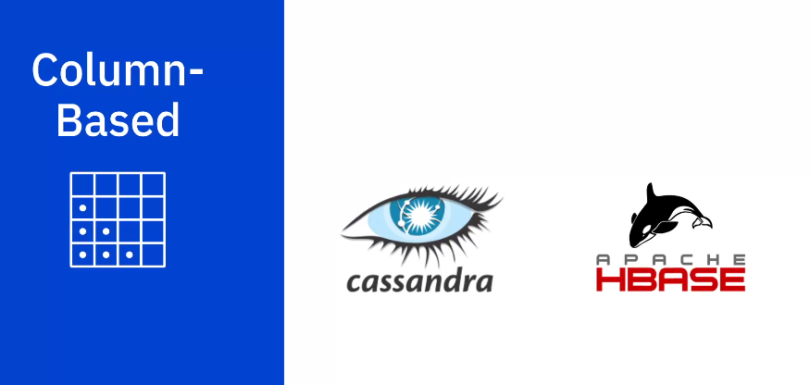

Graph Based

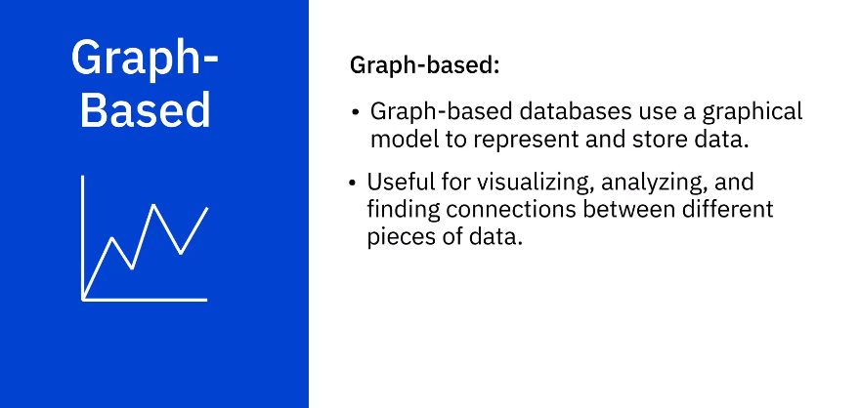

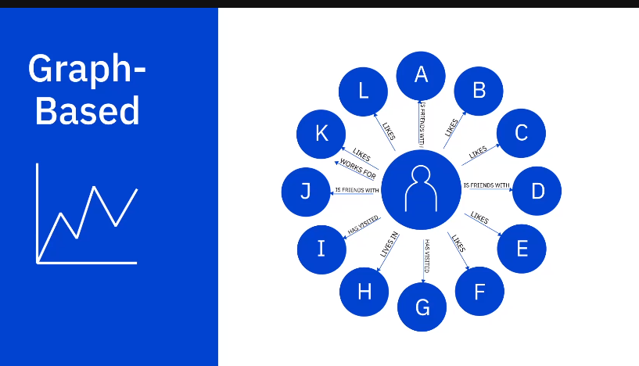

1. The circles arenodes, and they contain the data.
2. The arrows represent relationships.
3. Graph databases are an excellent choice for working with connected data, which is data
4. that contains lots of interconnected relationships.

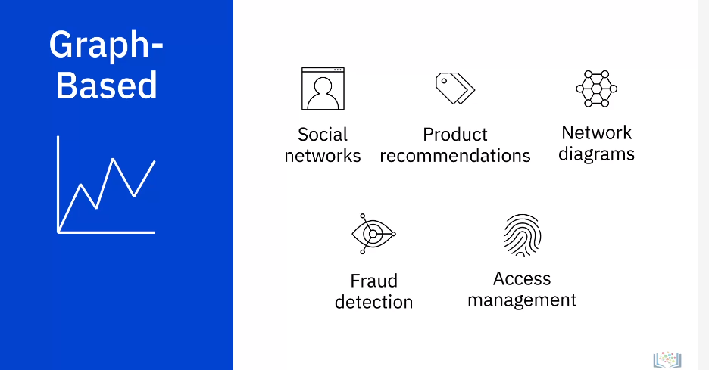

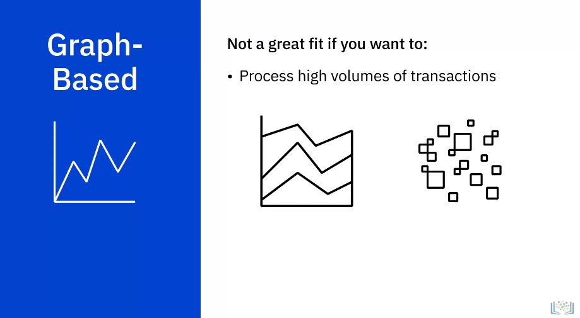

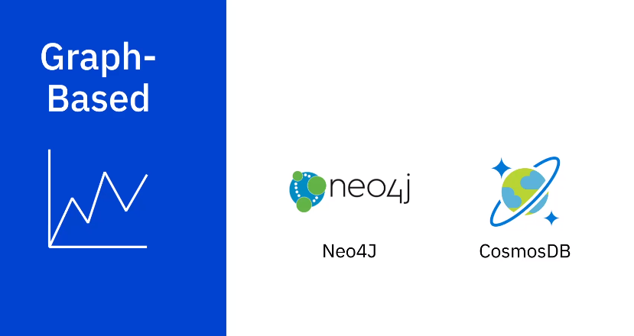

Advantages of NoSQL

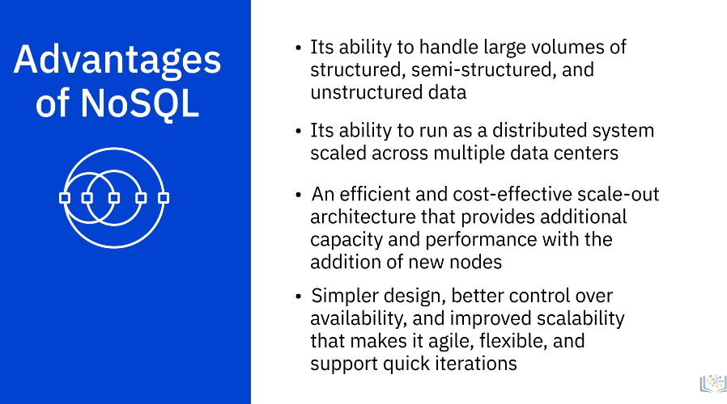

Key Differences between Relational and Non-relational Databases

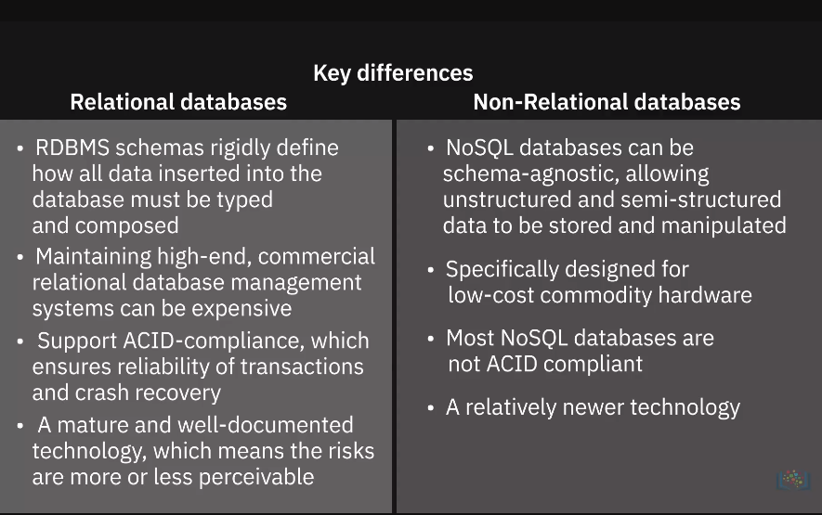

**Video: Data Warehouses, Data Marts, and Data Lakes (7:16)**

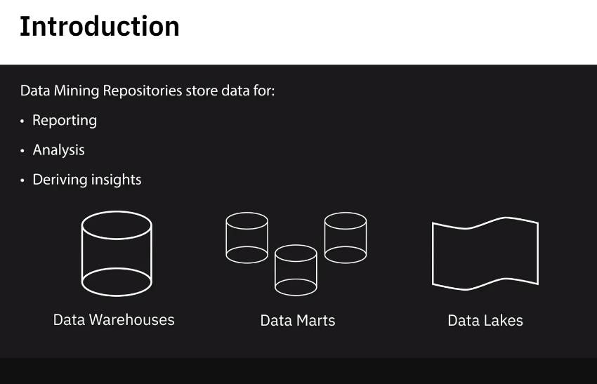

Data Warehouses

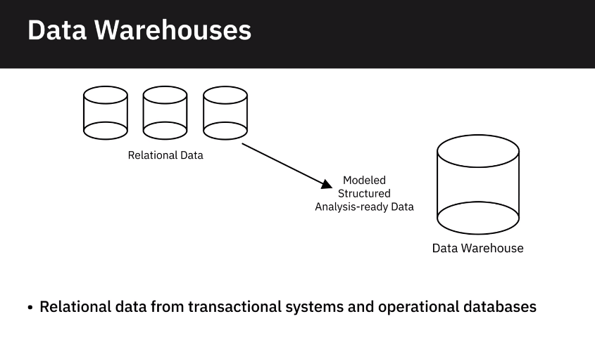

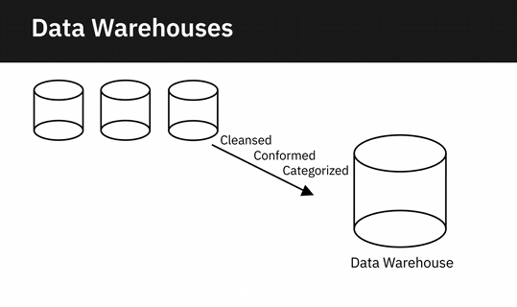

1. When data gets loaded into the data warehouse, it is already modeled and structured for a
2. specific purpose, meaning it's analysis-ready.

Examples:

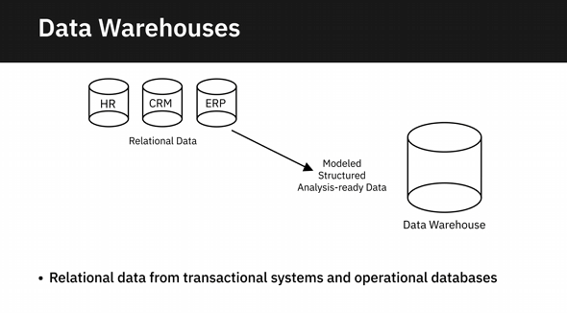

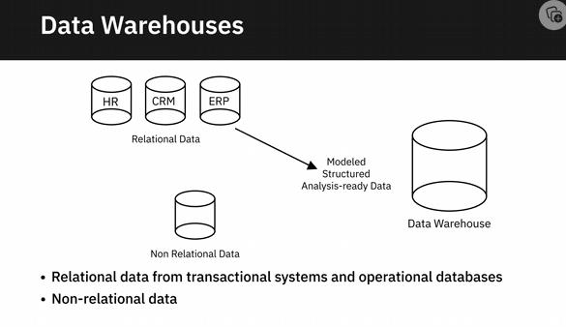

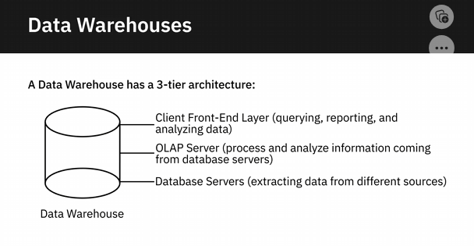

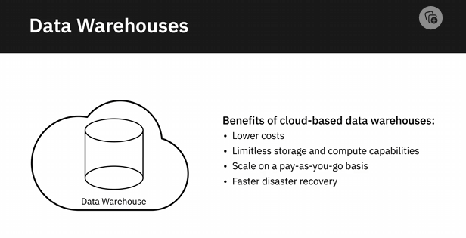

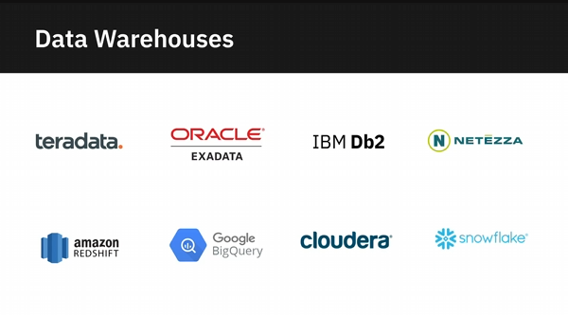

Data Marts

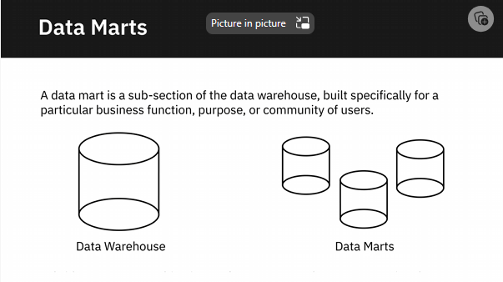

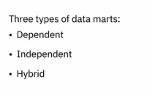

Dependent Data Mart

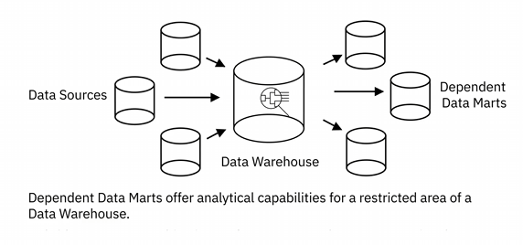

Independent Data Mart

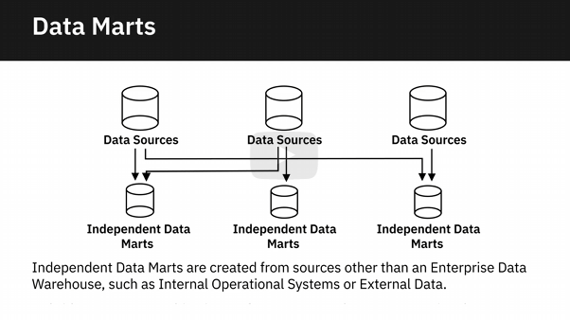

Hybrid Data Mart

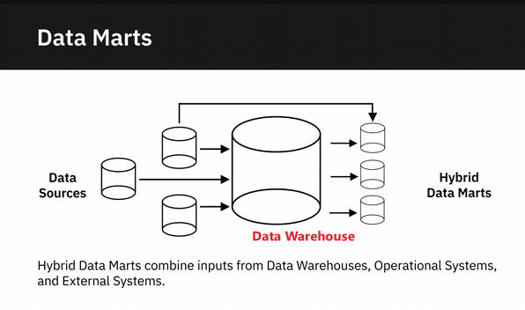

1. **The difference also lies in how data is extracted from the source systems, the transformations**
2. that need to be applied, and how the data is transported into the mart.
3. Dependent data marts, for example, pull data from an enterprise data warehouse, where data
4. has already been cleaned and transformed.
5. Independent data marts need to carry out the transformation process on the source data
6. since it is coming directly from operational systems and external sources.
7. Whatever the type, the purpose of a data mart is to:
8. provide users' data that is most relevant to them when they need it,
9. accelerate business processes by providing efficient response times,
10. provide a cost and time-efficient way in which data-driven decisions can be taken,
11. improve end-user response time; and
12. provide secure access and control.

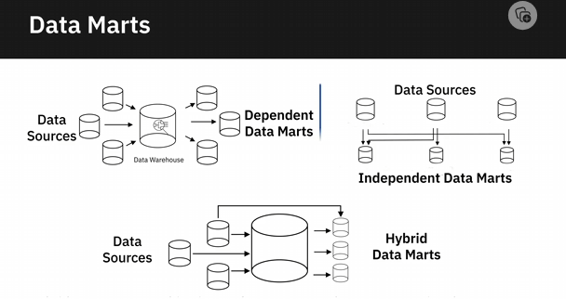

Purpose of Data Mart

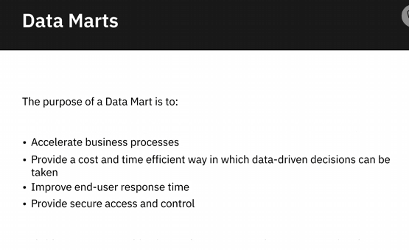

Data Lake

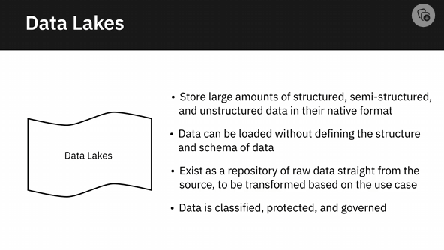

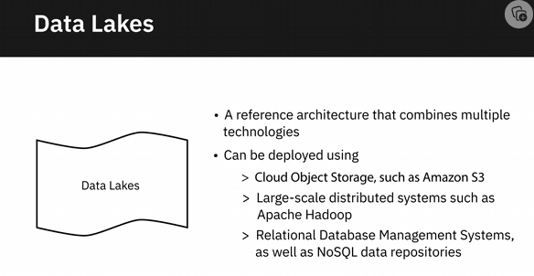

Benefits

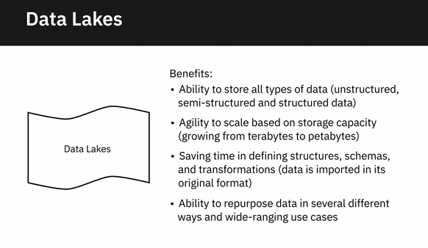

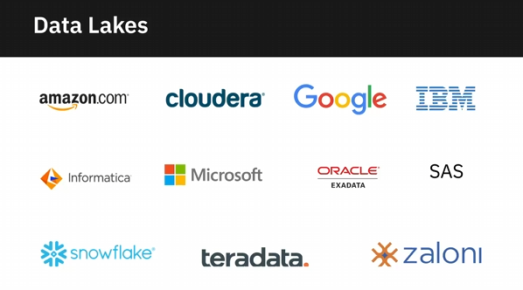

**Video: (Optional) Data Lakehouses Explained**

Enterprise Data Warehouses

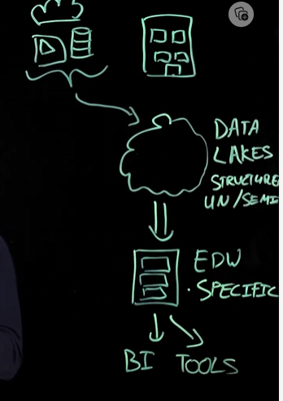

Data Lake: cost-effective way to store tons of data

But without governance and quality assurance, data lake becomes “data swamp”

Not built to perform complex data analysis.

Good at data query,

Data Lakehouse: flexibility + cost effectiveness of data lake

+ We get performance and structure/government from a data warehouse.

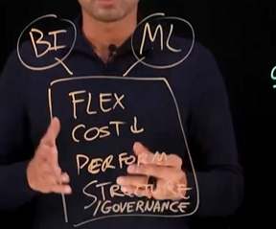

**Video: Viewpoints: Considerations for Choice of Data Repository (6:25)**

**Video: ETL, ELT, and Data Pipelines (6:37)**

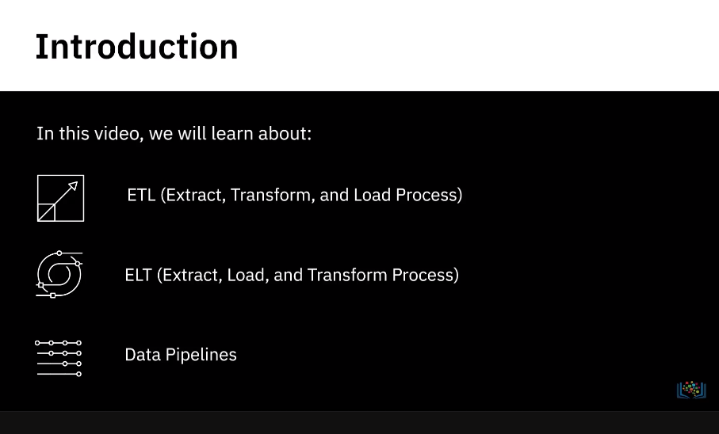

Extract transform and load process (ETL) 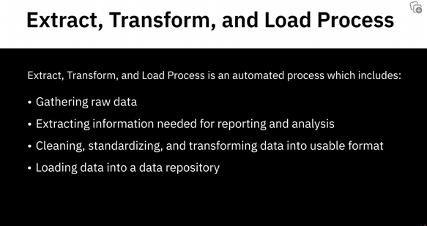

Extract

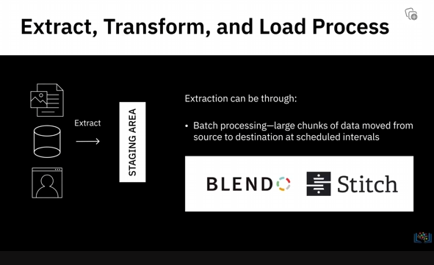

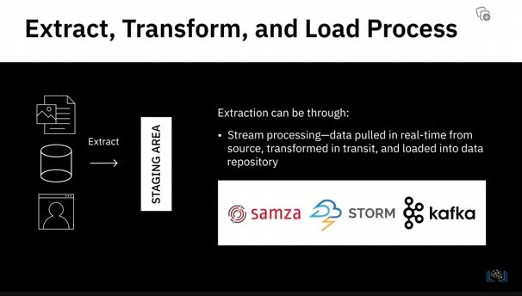

Transform

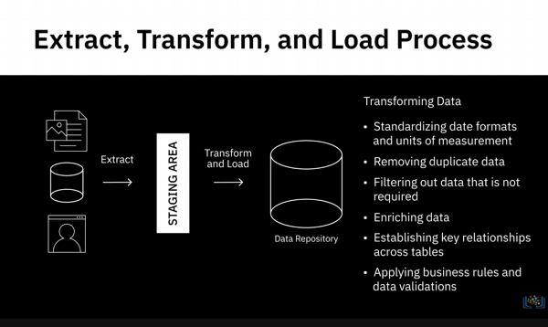

Load

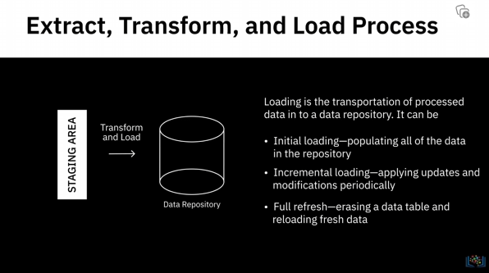

Load Verification

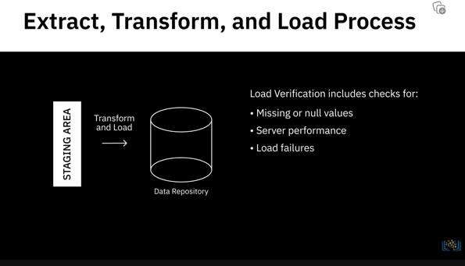

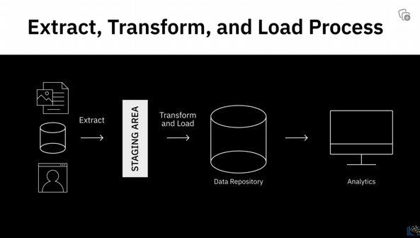

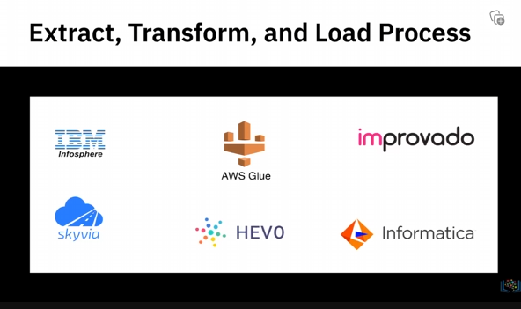

Extract Load and Transform

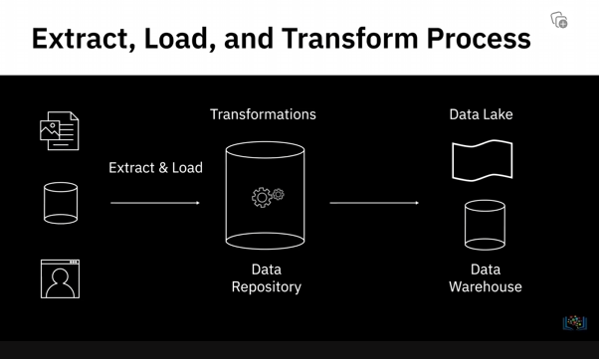

Relatively new

Advantages

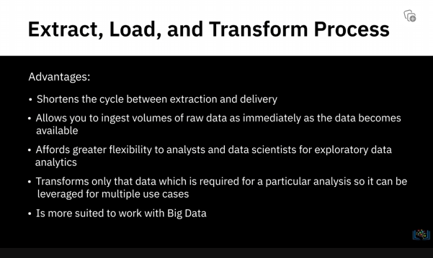

Data Pipelines

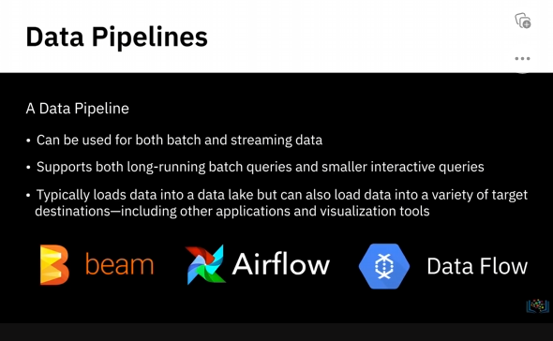

**Video: Data Integration Platforms (4:48)**

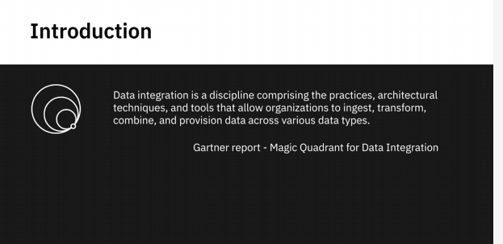

**Usage Scenarios**

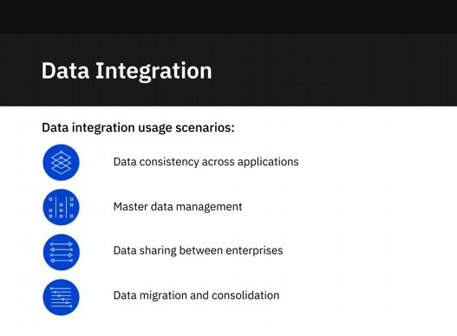

**Data Integration Inclusions**

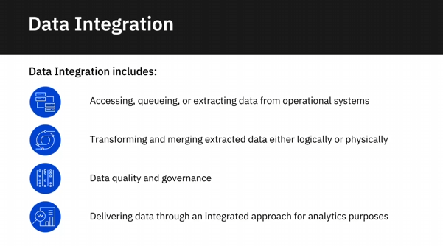

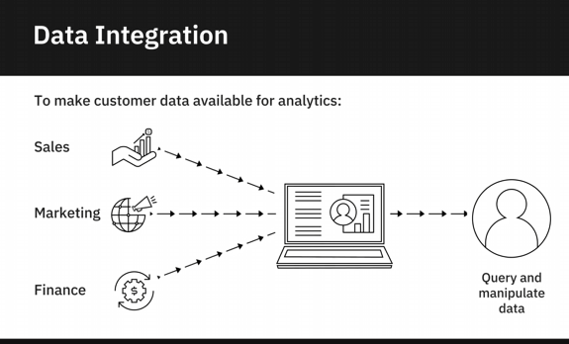

**Capabilities of Data Integration Platform**

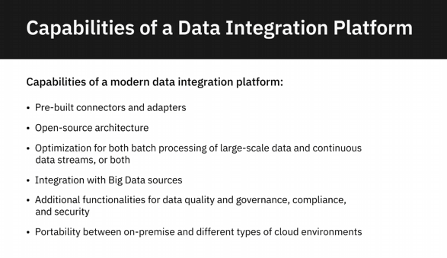

**Data Integration Tools**

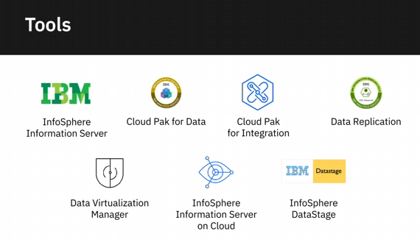

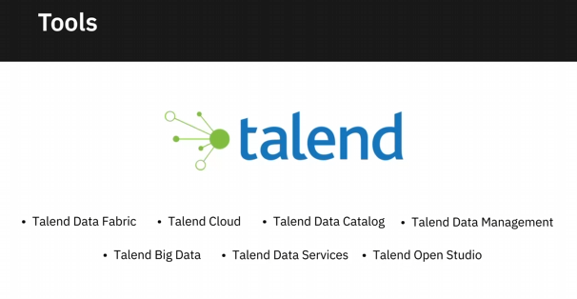

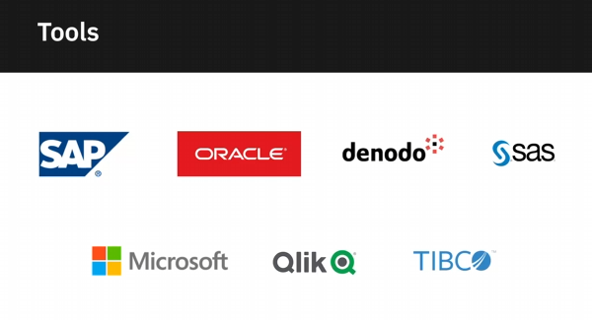

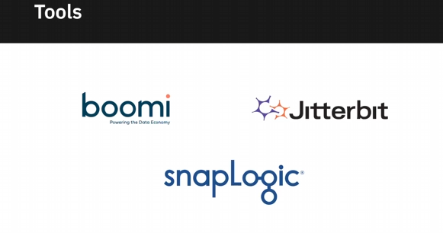

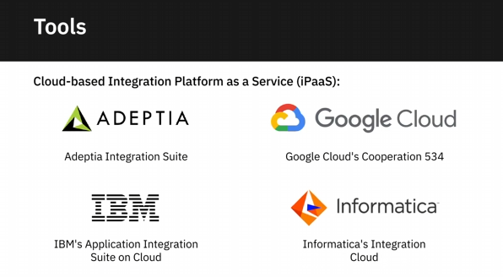

**Video: Viewpoints: Tools, Databases, and Data Repositories of Choice (6:38)**

In this video we will listen to data

professionals talk about some of the

data engineering tools,

databases, and data repositories they

work with.

The ecosystem of data engineering is

very very vast.

We work especially with, mostly with,

open source tools. So, we work with

RDBMS databases like MySQL. We work with

NoSQL databases like MongoDB, Cassandra,

graph databases like Neo4j.

Python is pretty much indispensable.

So, whatever feature we feel missing in

our data engineering space,

we first try to, you know,

use Python to

get that into a place. And then over a

period of time we see if any product can

take its place. We also work with

tools like

Apache Airflow to create

data pipelines. We work with tools like

Spark for big data processing.

We work with

Kafka to handle streaming data.

We work with Talend for

ETL functionality. We also work with

tools like

Beautiful Soup and Scrappy for

web scraping. And we also look at

a variety of cloud storages for our

archival and then for our daily storage

purposes. Before Coursera I was

in a non-profit where SQL server was the

data repository and we use a SQL server

integration service, as well as Okada

to do

data integration. And in Coursera

AWA's worksheet is our data warehouse.

And we use

AWS A3 as our data lake.

We have internal tool to do...

to build up,

to build our ETL pipeline, and schedule

our ETL pipeline but now we are

moving to use an open source tool

called

Apache Airflow to do

data orchestration. I work with

relational databases such as IBM DB2,

PostgreSQL, and Microsoft SQL Server.

And I also have exposure to working on

NoSQL database such as

Cassandra and MongoDB. And I worked on

streaming technologies

for replication such as WebSphere MQ,

and also for back-end processing

by moving the transactional data

by using the Kafka queues onto the

back office databases.

At the same time, I also worked on

data engineering tools, or

data movement tools,

for moving data from one data source to

another. For example, I worked on

SSIS by building these data movement

packages.

At the same time I also worked on this

cool tool called

NiFi. I think it's a... this NiFi

is now maintained by

Apache Foundation

which is an open source foundation.

Which I highly recommend looking at

some of their projects

because they're all

open source,

the code is open. You can

go through the source code and learn

a lot about some of these products and

even projects. And you can,

if you're an enthusiast, can have a lot of

time on your hands you can even

contribute

to some of these projects.

I digress but

NiFi can be used to

move data between heterogeneous

data sources.

And I also developed my own

scripts such as Shell, and Perl, and

written Java APIs to move

data between different applications

and vendors.

So, most people, myself included,

who've done work in data engineering

have had to work with a number of

databases and tools.

Having spent a good part of my data

career at IBM,

I had to do a lot of work with the IBM

DB2 database

and later became a product manager

for it.

But I've also had to work with other

databases like MySQL

and PostgreSQL. And then as

part of my job evolved, I had to pick up

skills in

Big Data Systems like Hadoop and Spark.

So, it's important that as a data

engineering, a field that continues to

evolve, you need to, you know,

come up with... you need to become

a lifelong learner

and keep picking up skills that are

going to be required

for your job and the problems that

you're trying to solve.

So, as long as you're good with

data fundamentals,

you should be able to quickly pick up

these new skills and technologies.

The primary product that I've worked

with my entire career

is IBM's DB2 on mid-range platforms, so,

on Linux, Unix and Windows.

To me this is a great choice in the

relational database space.

I also work very heavily with

AWS products.

I've been working with databases on RDS,

Microsoft SQL Server. We've done

a little bit of MariaDB there. We also do

MariaDB outside of that

on our own servers. Those are the primary

relational database products that

we work with. There are a ton of other

tools we work with in order to properly

manage those

or to manage workflows around those.

Of course Github or Git.

You have to be familiar with those.

Those are are integral to

any process in a DevOps organization or

in most non-DevOps organizations at this

point. Using Jenkins... we use

Jenkins for a lot of things; to spin up

containers, to do maintenance jobs, to

manage code deploys. There's a

lot of important stuff that

that we do with Jenkins as well.

we use Liquibase.

Liquibase is actually excellent.

We use it with containers

to very easily have some management of

the changes that are made to our

database schemas.

**Foundations of Big Data**

Definition

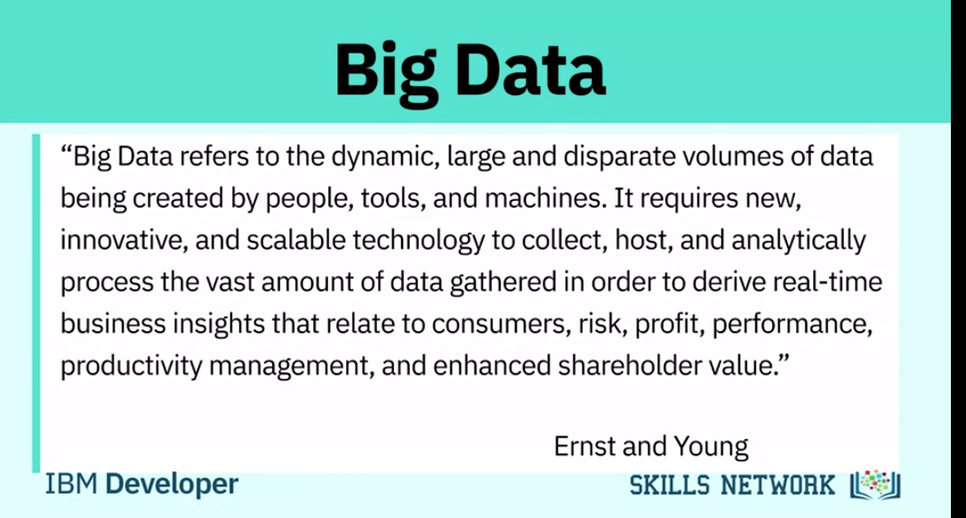

**Characteristics**

**Velocity**

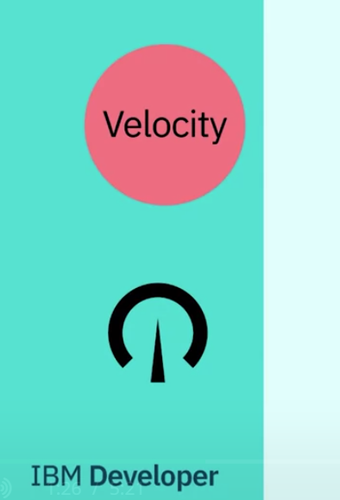

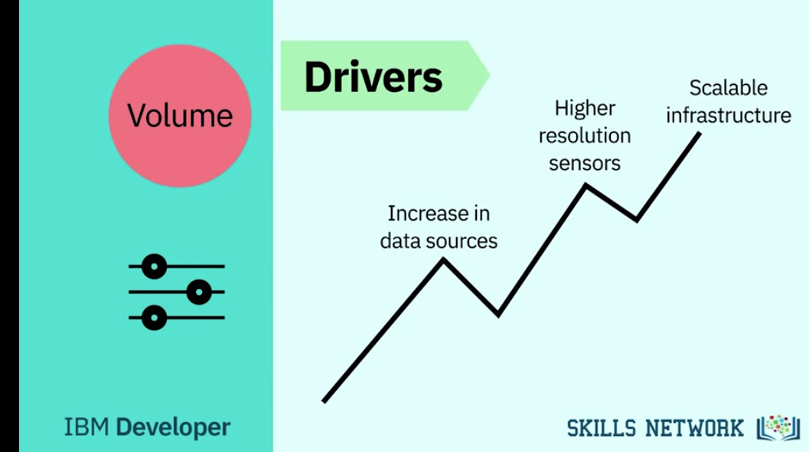

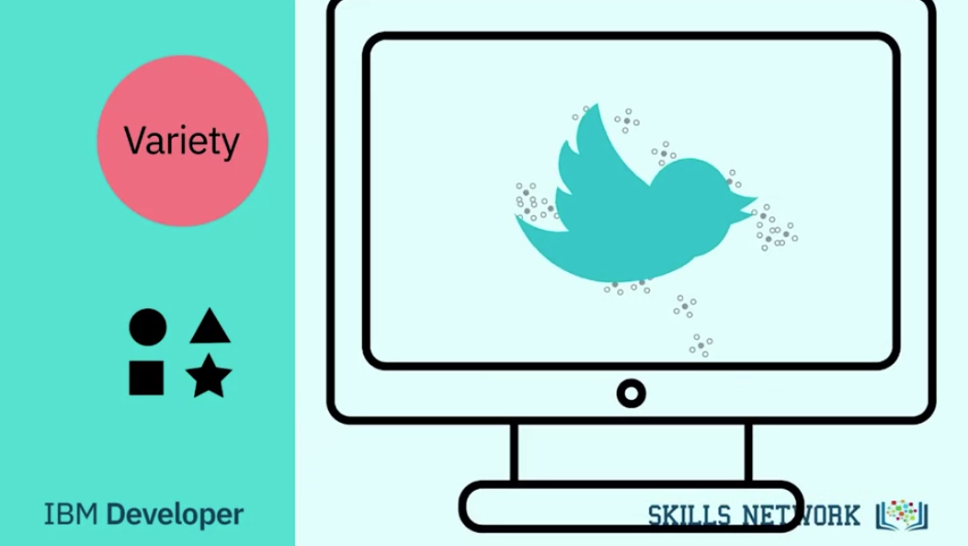

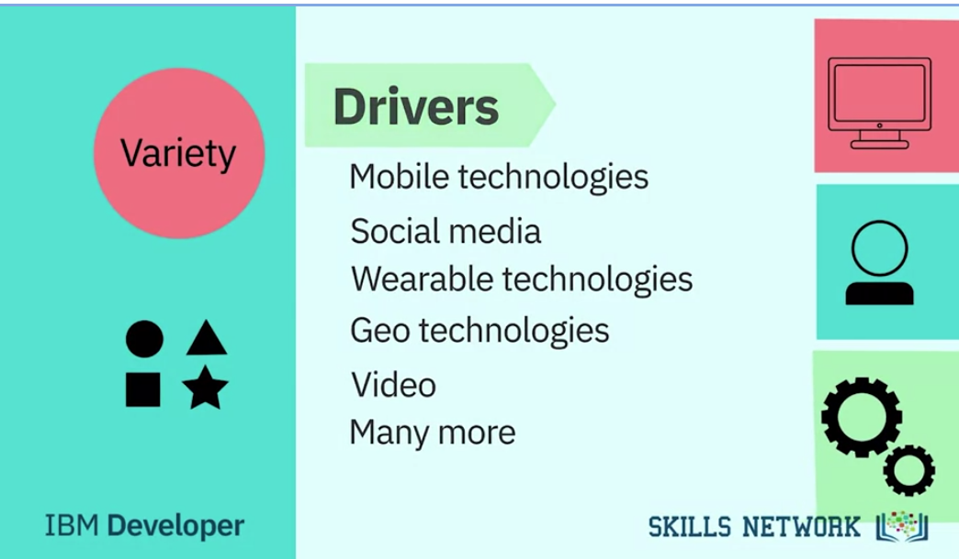

**Values**

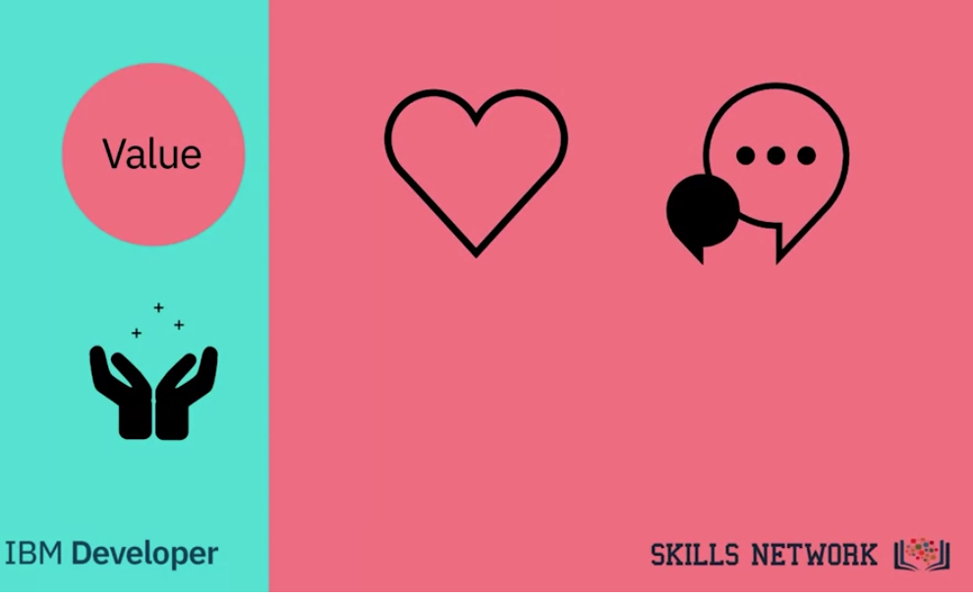

**Big Data Processing Tools: Hadoop, HDFS, Hive, and Spark**

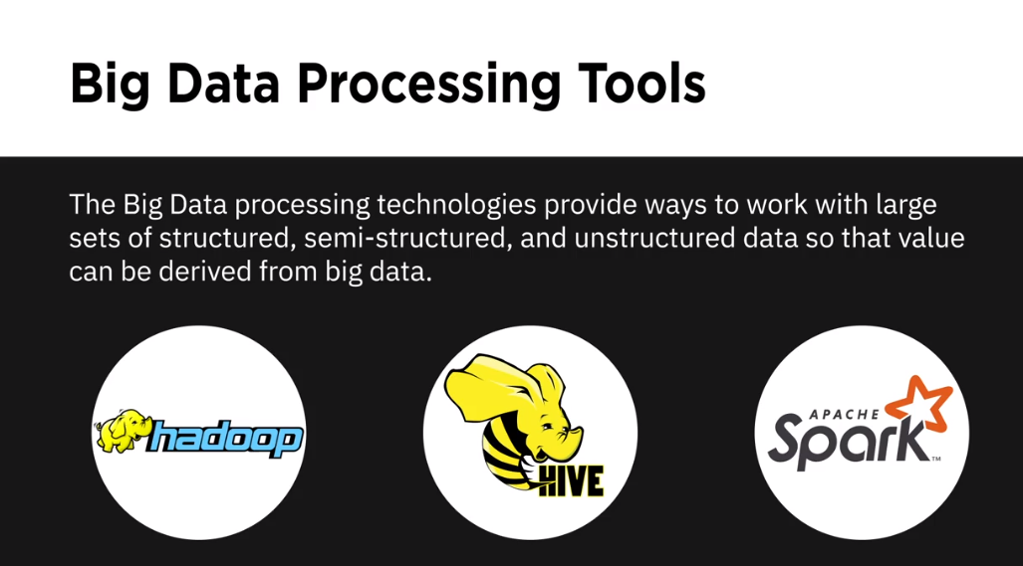

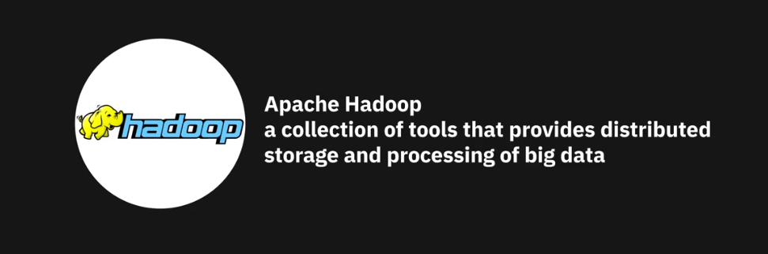



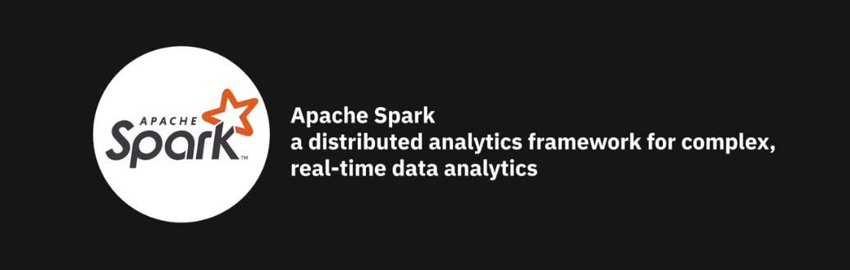

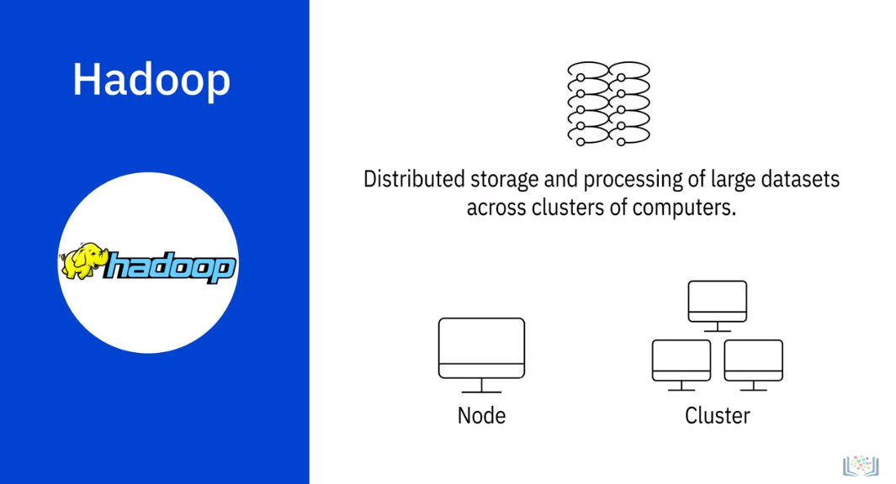

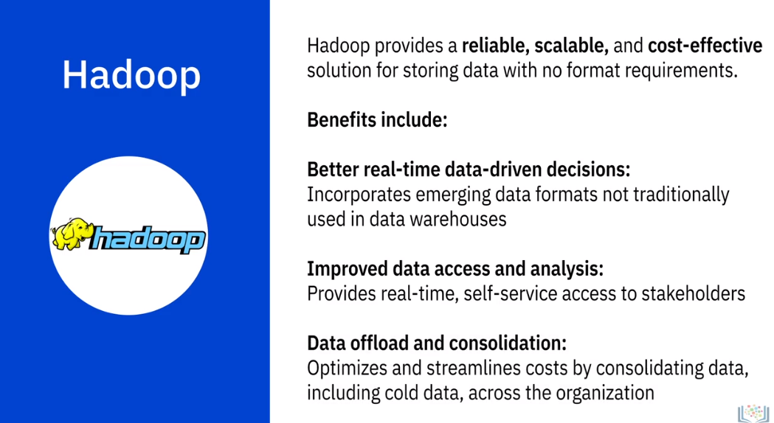

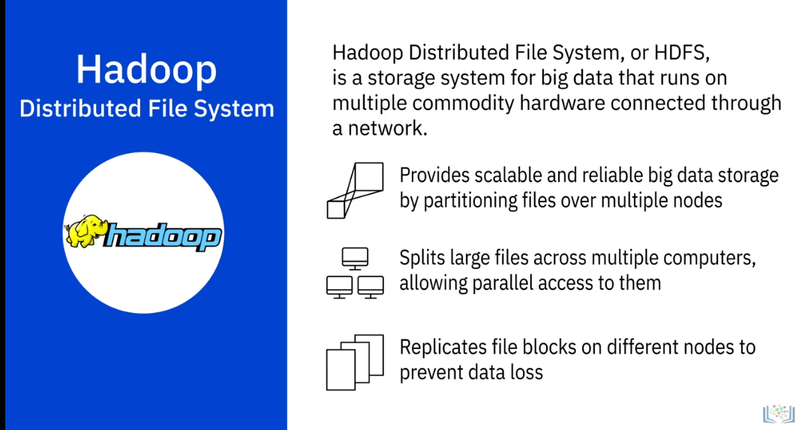

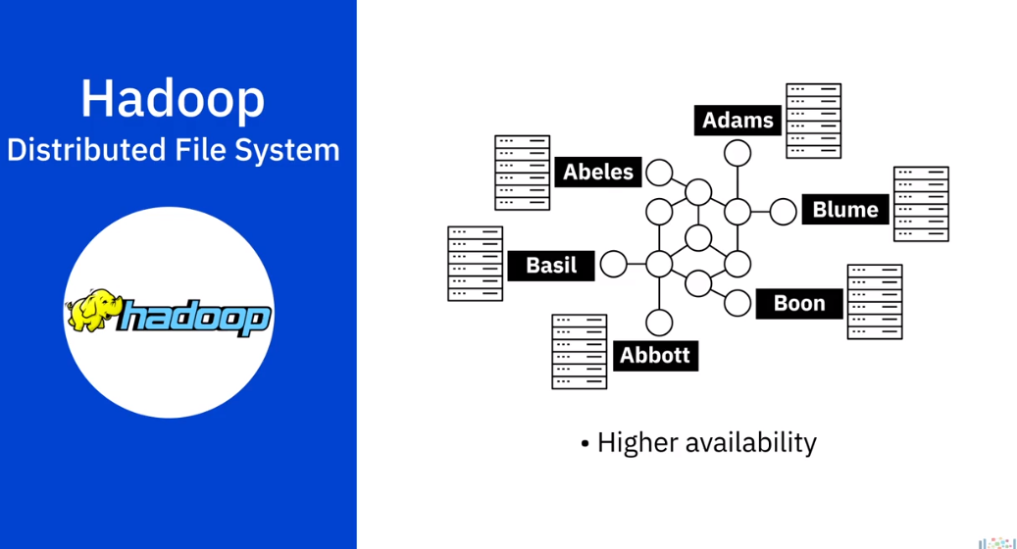

To reconstruct the entire phonebook, your program would need the blocks from every server

in the cluster.

HDFS also replicates these smaller pieces onto two additional servers by default, ensuring

availability when a server fails,

In addition to higher availability, this offers multiple benefits.

It allows the Hadoop cluster to break up work into smaller chunks and run those jobs on

all servers in the cluster for better scalability.

Finally, you gain the benefit of data locality, which is the process of moving the computation

closer to the node on which the data resides.

This is critical when working with large data sets because it minimizes network congestion

and increases throughput.

Benefits that com from using HDFS

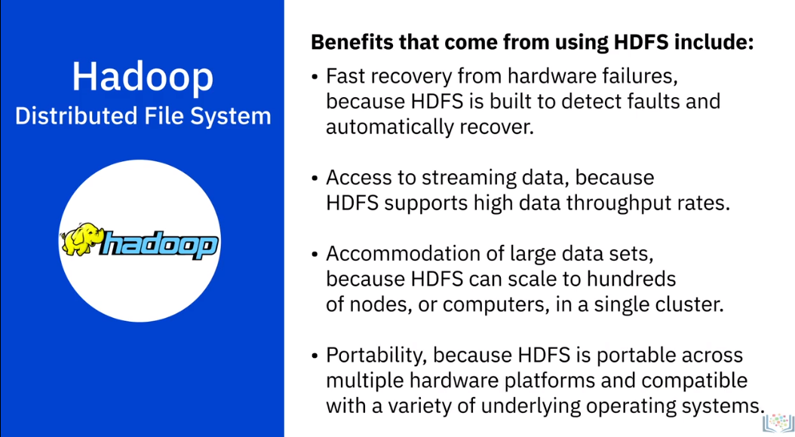

Hive

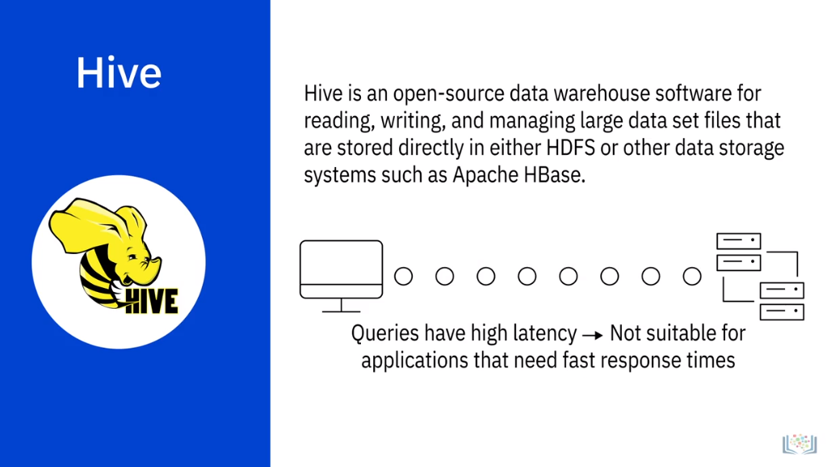

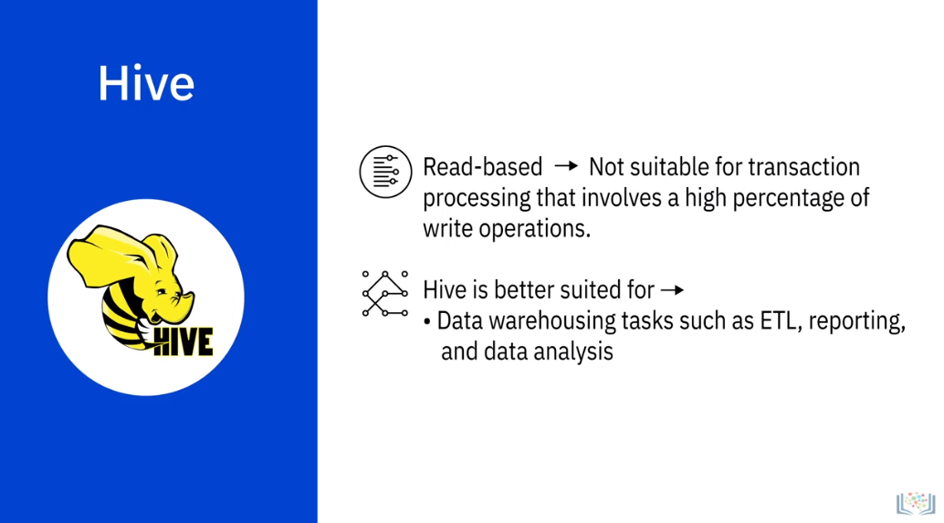

**Spark**

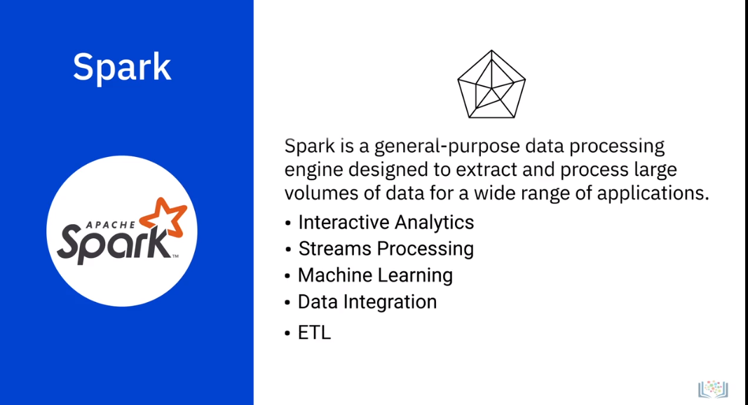

**Spark Key Attributes**

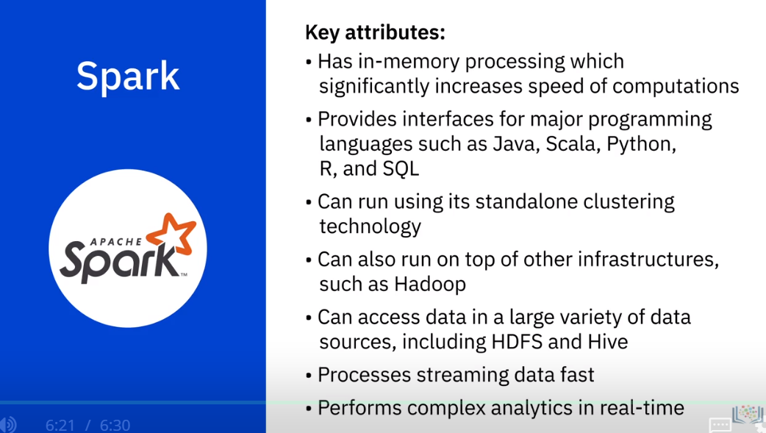

**Viewpoints: Impact of Big Data on Data Engineering**

**In this video, we will listen to**

**several data professionals talk about the impact of Big Data on data engineering.**

**So how is the Big Data changing and shaping the field**

**of data engineering. Big Data can be described as the data that**

**has these four characteristics, also known as four Vs; velocity,**

**veracity, volume, and variety. Big Data has had a**

**major impact on data engineering, making it a much**

**more diverse and a rich field. It's quite natural because**

**with all the data that the organizations are collecting**

**these days, being able to make sense of it and derive insights**

**from it is becoming more and more relevant and critical. And that has opened up a vast**

**opportunity. Not only have we seen the emergence of new**

**technologies and products related to working with Big**

**Data, it's also created a huge demand for professionals who can**

**effectively work with large volumes and variety of data,**

**both for building and managing these big data systems, but also**

**for analyzing data within them. In the pre-IoT on**

**social media days, the number of ways you can**

**ingest the data into a database are really small. Like**

**for example, you have a data entry analyst that's putting data into these**

**databases at a very slow pace. But in the past decade,**

**especially with these all new gadgets and devices talking to**

**each other on these APIs, pushing latest updates to**

**these different gadgets, the nature of the data itself**

**changed. As a result of this evolution, the data engineering**

**envolved as well because your traditional RDBMSes are not a**

**one-size fits-all solution like a lot of database administrators**

**and data engineers discovered in a hardware. With these variety of**

**data sources and volumes, the field of data engineering**

**itself evolved significantly, and data engineers ended up**

**inventing these new data sources such as Google BigTable,**

**Cassandra, Graph-based Databases, Hadoop, MapReduce to analyze these**

**petabytes of data. So data engineers ended up writing their**

**own tools and also learning and working on new technologies. So**

**there was a big evolution due to Big Data. Big Data has**

**fundamentally changed things in that organizations are much more**

**accepting of storing large amounts of data. Storage for data, actual disk space, is no**

**longer a big issue. We've gotten to the point where we stored a**

**lot more data, and that's what the big data buzzword storm has**

**really brought about. That, and better ways of handling large**

**amounts of data. You know, we can think of Big Data in**

**different ways. There's obviously unstructured data**

**which has become a huge thing and is usually not handled**

**within databases. If it is, it's handled in something like MongoDB.**

**And then there's also just a vast amount more of data that**

**we're dealing with.**